

**

Faculty of Electrical Engineering and Computer Science

**Master Thesis**

EMI Filter Design and Verification using RF Simulation Tools and Measurements

**Md Moinuddin Biswas**

Matriculation Number: 5071889

A Thesis

presented to the

Bremen University of Applied Sciences

in fulfilment of the

thesis requirements for

the degree of Master of Science

in Electronics Engineering

**First Advisor: Prof. Dr. S. Peik**

**Second Advisor: Prof. Dr. Mirco Meiners**

Period: 01.06.2021 - 30.11.2021

**PREFACE**

The entire content of this master thesis is documented according to the research and simulation conducted in Hochschule Bremen. Plagiarism is avoided while writing this thesis paper. Some external source of contents like references and citations added in this thesis paper have been credited to their respective author.

Md Moinuddin Biswas

**ACKNOWLEDGEMENT**

The author of this thesis work would like to express his heartfelt thanks to Almighty first. The author would also like to thank his supervisor Mr. Prof. Dr. S. Peik for his unconditional support and guidance during the entire duration of this master thesis. His constant supervision, motivation, and guideline helped to understand and complete this work properly.

Lastly, the author would like to thank his family and friends for supporting and motivating throughout the completion of this thesis work.

**Abstract**

Modern technologies are depended on efficiency that includes reduction in size, cost, and supply power of a system. All these efficiencies come with the obvious generation of noise. The more a device is noise-free the more it becomes efficient. All the electronic devices are produced considering the effect of electromagnetic interference. This interference is defined as the noise that travels through the electronic components like resistors, inductors, capacitors, wires, printed circuit boards, or through the overall design. This form of electromagnetic interference (EMI) has a serious impact on malfunctioning. To reduce this interference a filter is used named electromagnetic interference (EMI) filter.

An EMI filter is ideally a low pass filter that prevents both high frequencies and noise flow while passing through the input. The magnitude of high-frequency signals will also be reduced by this filter. This filter is constructed with two lumped elements inductors and capacitors. There are several orders of this filter depending on the component's alignment and value.

This thesis work will deal with an EMI filter constructed with basic components. We will measure the unintended radiated electromagnetic wave from the test kit and the disturbance, also how much radiation actually produced. We will apply different valued inductors, capacitors, and chocks to measure the filter effect first and then we will synthesize the disturbances. Microwave Office software (AWR) will be used to calculate S-parameters to simulate the actual device. We are going to perform linear and nonlinear measurements to observe the filter performance as well. The simulation of this filter circuit will also be done both in frequency and time domain and at the end we will compare the performance analysis between the manufacturers’ circuit board and simulated filter.

Before starting the lab work, several filters will be designed and tested in the AWR platform to identify the least disturbance circuit. Hardware simulation will be performed after designing the proper filter schematic, and the printed circuit board accordingly.

Contents

List of Figures 6

List of Tables 8

Chapter One: Introduction 8

1.1 Literature review 9

1.2 Motivation 9

Chapter two: Theory 10

2.1 EMI in details 11

2.1.1 EMC compliance 11

2.1.2 EMI Definition 12

2.1.3 Electromagnetic Interference Classification 12

2.2 EMI Filter Design 13

2.2.1 Schematic Design 13

2.2.2 Common Mode Filter 14

2.2.3 Differential Mode Filter 16

2.2.4 Design Flow diagram 17

2.3 EMI Emissions Analysis 18

2.3.1 Conducted Emission 19

2.3.2 Radiated emissions 19

Chapter Three: Filter mode 20

3.1 Conducted Emission Analysis 20

3.1.1 Common Mode Interference 20

3.1.2 Differential Mode Interference 22

3.2 Material Selection for Hardware Design 23

3.2.1 Common Mode Choke 23

3.2.2 Lumped elements 25

3.3 Noise Source Design 26

3.4 Line Impedance Stabilization Network (LISN) 27

Chapter Four: Filter Behaviour Prediction 28

4.1 Linear Simulation 28

4.1.1 S-parameter measurement 28

4.1.2 Reflections on transmission lines 32

4.2 Nonlinear Behaviour 34

4.2.1 Harmonic Balance Techniques 35

4.2.2 Time-Domain Analysis 35

Chapter Five. Experimental approach and discussion 45

5.1 Case Study 1: 230V 50Hz line 45

5.1.1 Linear simulation 45

5.1.2 Nonlinear simulation 46

5.2 Case Study 2: Experimental Examples 48

5.2.1 USB cables 48

5.2.2 Ethernet cables 51

Conclusion 54

References 55

# List of Figures

Figure 01: Classes and subclasses of Electromagnetic compatibility. 9

Figure 02: Measurement relationship between EMC classes [2]. 10

Figure 03: Passive components, CMC and ceramic capacitor for building EMI filter [8]. 11

Figure 04: Standard schematic design of EMI filter [8]. 12

Figure 05: Hardware design of Common Mode Filter. 12

Figure 06: Expected input and output signal amplitude of a Common Mode Filter [9]. 13

Figure 07: Common Mode Filter circuit diagram for software simulation. 13

Figure 08: ‘Measured’ and ‘Simulated’ voltage measurement in time domain for square signal for Common Mode Filter. 13

Figure 09: Hardware design of a Differential Mode Filter. 14

Figure 10: Expected input and output signal amplitude of a Differential Mode Filter [9]. 14

Figure 11: Differential Mode Filter circuit diagram for software implementation. 14

Figure 12: ‘Measured’ and ‘Simulated’ voltage measurement in time domain for square signal for Differential Mode Filter. 15

Figure 13: Induced emissions in an EMI filter [11]. 17

Figure 14: Conducted Emissions path in a designed device. 18

Figure 15: Common mode part in an EMI filter. 18

Figure 16: Voltage measurement of a Common Mode Filter. 19

Figure 17: Current flow path in a Common Mode Filter. 19

Figure 18: Common mode radiation overview. 19

Figure 19: Differential mode part in EMI filter. 20

Figure 20: Voltage measurement of a Differential Mode Filter. 20

Figure 21: Current flow path in a Differential Mode Filter. 21

Figure 22: Differential mode radiation overview. 21

Figure 23: A Common Mode Choke. 22

Figure 24: Physical layout and circuit schematic of a Common Mode Choke. 22

Figure 25: Common mode current flow through Common Mode Choke. 22

Figure 26: Differential mode current flow through Common Mode Choke. 23

Figure 27: Impedance of a Common Mode Choke a. Measured b. Theory. 23

Figure 28: Lumped elements and current directions through them. 24

Figure 29: Noise signal generator (Comb generator), physical and circuit layout. 24

Figure 30: Hardware design of a Comb generator and the input power with frequency. 25

Figure 31: Circuit diagram of LISN. 25

Figure 32: Two port network diagram. 26

Figure 33: Definitions of four individual S-parameters. 26

Figure 34: S-parameters measurements of, a) CMF, b) DMF; 27

Comparison between measured and simulated measurements in dB for c) CMF, d) DMF. 27

Figure 35: Transfer functions of a) Common Mode Filter, b) Differential Mode Filter, c) Common Mode Choke, d) transformers. 29

Figure 36: Transmission line of a two-port network. 30

Figure 37: Insertion loss measurement of CM and DM filter in Hardware (measured) and Software (simulated) platform. 31

Figure 38: Power is reflecting to the source [21]. 31

Figure 39: Reflection loss of Common Mode Filter and Differential Mode Filter. 32

Figure 40: Circuit design of CMF voltage measurement in time domain. 33

Figure 41: CMF voltage measurement in time domain using sinusoidal signal. 34

Figure 42: CMF voltage measurement in Frequency domain using sinusoidal signal. 34

Figure 43: Circuit design of DMF voltage measurement in time domain. 34

Figure 44: DMF voltage measurement in time domain using sinusoidal signal. 35

Figure 45: DMF voltage measurement in Frequency domain using sinusoidal signal. 35

Figure 46: Multi-tone measurement process. 36

Figure 47: Circuit design of a) CM and b) DM filter with multi-tone signal source. 36

Figure 48: Voltage analysis of CMF and DMF for multi-tone input signal in time domain. 37

Figure 49: Voltage analysis of CMF and DMF for multi-tone input signal in frequency domain. 37

Figure 50: Power analysis of CM and DM filter for multi-tone input signal in time domain. 38

Figure 51: a) Hardware simulation for CM filter, b) Hardware simulation for DM filter. 39

Figure 52: a) Software simulation for CM filter, b) Software simulation for DM filter. 40

Figure 53: Noise power for both filter both in Software and Hardware platform. 40

Figure 54: Comparison between Hardware and Software simulation with different components. 41

Figure 55: Comparison between Hardware and Software simulation with different components. 42

Figure 56: Model setup for the test. 43

Figure 57: Circuit setup for the test. 43

Figure 58: a) CMF s-parameters (s11, s21) for both 2x100pF cap and 2x2200pF cap 44

b) DMF s-parameters (s11, s21) for both 2x100nF cap and 840pF & 470pF cap 44

c) Comparison between CMF & DMF insertion loss (proprsed-2x100pF & 840,470pF) 44

d) Comparison between CMF & DMF insertion loss (available-2x2200pF & 2x100nF). 44

Figure 59: Time domain response of input and output CMF & DMF for 2 set of capacitor. 45

Figure 60: Frequency domain response of input and output harmonic voltage of CMF & DMF for 2 set of capacitors. 45

Figure 61: Frequency domain response of input and output harmonic power of CMF & DMF for 2 set of capacitors. 46

Figure 62: USB cable and its core layout [26]. 47

Figure 63: Circuit schematic of DM filter and CM filter with USB connection. 47

Figure 64: Common Mode Filter & Differential Mode Filter measurement for USB 1.0 cable towards the load a) CMF Power input and output in time domain (Pharm). b) CMF Input & Output harmonic power comparison. c) CMF voltage input and output in time domain (Vharm). d) CMF Input & Output harmonic voltage comparison. e) DMF Power input and output in time domain (Pharm). f) DMF Input & Output harmonic power comparison. g) DMF voltage input and output in time domain (Vharm). h) DMF Input & Output harmonic voltage comparison. 48

Figure 65: Ethernet cable and port having male and female port. 49

Figure 66: Circuit schematic with Common Mode Filter. 49

Figure 67: Common Mode Filter for cat5 Ethernet cable towards the load in frequency domain a) Voltage input AWR (Vharm) b) Voltage output Measured (Vharm) c) Power input AWR (Pharm) d) Power output Measured (Pharm). 50

Figure 68: Circuit schematic with Differential Mode Filter. 50

Figure 69: Differential Mode Filter for cat5 Ethernet cable towards the load in frequency domain a) Voltage input AWR (Vharm) b) Voltage output Measured (Vharm) c) Power input AWR (Pharm) d) Power output Measured (Pharm). 51

# List of Tables

Table 01:Hardware measurement of CMF with 2 set of capacitors…………………………40

Table 02: Hardware measurement of DMF with 2 set of capacitors…………………………40

Table 03: Software measurement of CMF with 2 set of capacitors…………………………..41

Table 04: Software measurement of DMF with 2 set of capacitors…………………………..41

# Chapter One: Introduction

## Literature review

The electromagnetic interference filter is a critical part of the electronic study that estimates device efficiency. Noise is a highly prominent issue in electrical systems or devices that cannot be avoided and is created in a variety of ways. Depending on its function or purpose, each equipment deals with a distinct form of noise. These noise may be reduced using two simple and effective approaches. One is filtering, and the other is shielding. Despite the fact that these two approaches are intended to be used for various noise levels in different frequency bands. Filtering is a technique of removing undesired signals that occur while connecting to a signal generator. A filter is a device in an electronic study that is meant to bypass undesirable frequencies or frequency ranges. A filter response can also be simulated in both the frequency and time domains. In actuality, a variety of filters are accessible in electronics. They are classified based on input and output demand. An electromagnetic interference filter is a filter that merely serves to suppress noise, regardless of whether it is conducted or radiated. The major difference is that it is offered with a metal shield to reduce radiated noise. However, in the situation of conducted emission, it is quite advantageous because it is equipped with a compensated choke. In general, an EMI filter is placed between the source and the load to ensure that no noise is transmitted to the other components connected to it. EMI filters are employed in a variety of electronic circuits, including laboratory equipment, computer equipment, radio equipment, medical equipment, military equipment, and so on.

## Motivation

It is very important to set a goal before starting designing and implementing a device especially if it is an efficiency regulator. Before building an EMI filter, it is essential to understand the filter's behaviour and what it will do, how to construct this filter, how this filter will function, where such a filter may be used, and how efficient this filter will be in terms of cost and size.

What can an EMI filter do?

EMI filter is called electromagnetic interference suppression filters that is an effective medium to protect against harmful electromagnetic interference impacts. Electromagnetic noise that is transmitted through conduction path, can be suppressed by attaching this filter. These filters can extract the unwanted induced current while allowing the desirable currents to flow to the output. In a certain situation, it delivers extra currents to the ground so that the rest of the connectivity remains secure from harm.

How this filter can be designed?

An EMI filter is a low pass filter that enables only low-frequency signals to pass through while preventing other frequencies or frequency bands from passing through. As a result, it may also be made in the form of a low pass filter. In reality, it is usually an LC filter with a linked inductor instead of an inductor. Coupled inductors are intended to be used because they may enhance or reduce the voltage or current moving across the circuit while electrically isolating the other devices. However, it has recently been shown that a Common Mode Choke may be used in place of a coupled inductor. A Common Mode Choke acts as a filter, neutralizing the common mode noise generated by the circuitry. The use of capacitor is significant in the construction of this filter. In our designed filter two sets of capacitors are used to minimize two different noises. To regulate common mode noise and differential mode noise, one set of capacitors is used in series with the choke and another set is used in shunt with the choke. Despite their diverse purposes, the value of these capacitors might affect opposite noise.

How does an EMI filter function in an electrical circuit?

The frequency of the generated electromagnetic noise will be higher in range. As a result, EMI filters are built as low-pass filters, which block or sift out high frequencies while allowing lower frequencies to pass through. There are several types of EMI filters intended to reduce particular noise frequencies while allowing others to flow freely. Following the completion of the filtering operation, unwanted noise is diverted away from the device and sent to the ground. Some filters may reroute the undesirable currents back to the source of the noise, while others may not and consume that current.

Where can we place or install this filter?

Electromagnetic interferences can be formed inside an electrical equipment due to a mismatch in the impendence of associated wire. Voltage variations in conductors can also cause interferences. As a result, a proper configuration of this filter for the device is required. The installation of this filter varies depending on the device it is utilized in. If the installation is not perfect, the system will not function properly. Proper component and wire placement will reduce propagation and vulnerability. In general, a filter should not be put too close to the source or the load, or too far away from the power line. When the installation is closed, the filter is unable to finish the filtering process effectively, and the signal escapes without being suppressed by the filter and is directly connected to the other end, resulting in interference. It is preferable if the connecting cable is twisted pair since it may eliminate high-frequency interference signals.

EMI filters play an important role in today's electronic and electrical signal processing. This thesis will focus on the overall performance of an EMI filter with both linear and nonlinear features, as well as responsiveness in both the frequency and time domains.

# Chapter two: Theory

## EMI in details

### EMC compliance

Electronic or electrical equipment in a system create electromagnetic interference called radiated and conducted emissions. These emissions and interference have an impact on the overall operation of the system and might have unfavourable consequences such as physical damage to the equipment. Electromagnetic compatibility (EMC) is the capacity of a device to work properly in an electromagnetic environment without creating undue electromagnetic interference [1]. EMC's primary goal is to restrict the formation of unwanted signals as well as the propagation and receipt of electromagnetic radiation as an output signal.

There are two types of electromagnetic compatibility (EMC). Each of these categories is split up into two subcategories. Understanding and recognizing any or all of these aspects can help define EMC.

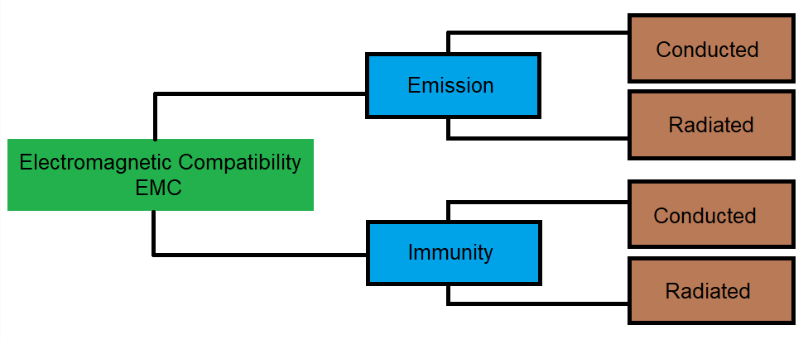

Figure 01: Classes and subclasses of Electromagnetic compatibility.

Emission is the intentional or unintentional generation of electromagnetic energy by a source that is released into the environment. EMC takes into account these undesirable emissions as well as actions that primarily decrease undesired emissions. Susceptibility or radio frequency interference (RFI) refers to electrical equipment that is disrupted or fails as a result of undesired transmissions [2]. In the case of immunity, a system or device functions correctly when a radio frequency is present. Hardening of equipment is also referred to as susceptibility or immunity.   
  
The coupling by which the radiated interference reaches the victim is a third difficulty that is a prevalent component of EMC.

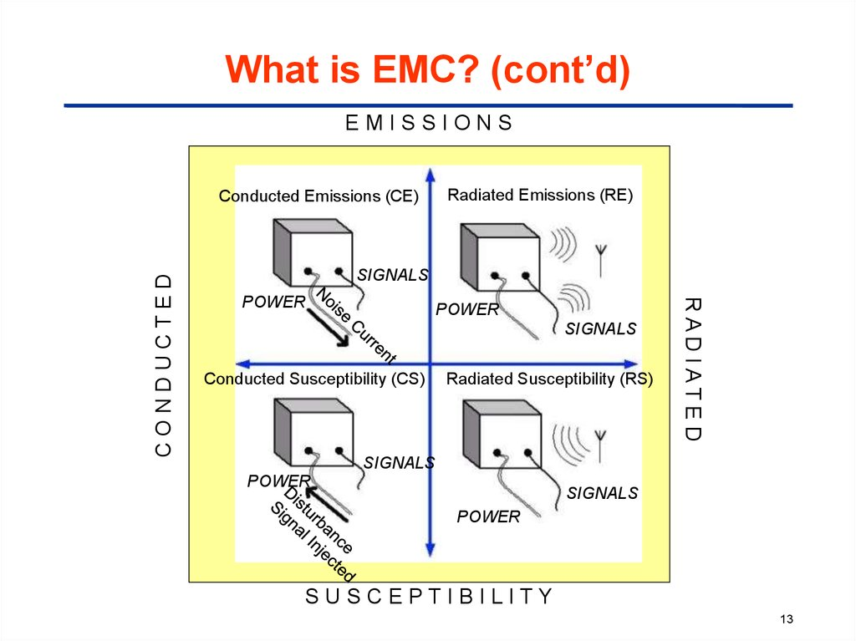

Figure 02: Measurement relationship between EMC classes [3].

### EMI Definition

Electromagnetic interference is defined as an electromagnetic disturbance that can affect the performance of a device, equipment, system, or subsystem and cause malfunction of the equipment that generates electromagnetic induction or emits electromagnetic radiation.

Electromagnetic (EM) waves are generated while colliding an electric field with the magnetic field. EM Waves can travel at a very high speed like the speed of light in a vacuum and can propagate through anything, whether it is air, solid materials, or waves [4]. They occur when an electronic device is not shielded from an electromagnetic field. EMI may be detected by any device that includes electronic circuitry and is linked to a power supply.

EMI is described as a combination of two or more waves that can produce bigger, smaller, or equal measured waves than the originating wave [5]. Therefore, the resulting wave may possibly be different from the original waves and may also be unsuitable for its purpose.

### Electromagnetic Interference Classification

1. EMI can be triggered by a number of factors. EMI is categorized based on how it is produced:

Man-made EMI: This type of EMI is generally generated by electronic circuits or electrical equipment [6]. Examples include power lines, car ignitions, fluorescent lights and so on.  
  
Naturally caused EMI: This type of EMI can be generated by many sources, such as extraterrestrial sources like radiation from the sun and galactic sources like radio stars, galaxies and other cosmic sources, atmospheric charges or discharges like lightning.

ii. The second method of classifying EMI types is based on their duration:

Continuous Interference: If a circuit is connected to a source and emits a continuous signal, then this type of EMI generally emanates from that source. However, continuous background noise can originate in a variety of ways, either man-made or natural.

Impulse noise: Lightning, ESD, and switching systems are all sources of impulse noise, which is a kind of EMI. This sort of EMI might be artificial or natural.

iii. EMI can also be classified based on its bandwidth.

Narrowband: This EMI is most likely caused by a single carrier source. Intermodulation and other kinds of distortion generate signals that are also type of narrowband EMI [7]. It can occur at any point on the spectrum. It may be liable for interfering with another user.

Broadband: Broadband EMI may be produced by a variety of sources. Broadband interference caused by humans might occur from sources that continually create sparks.

## EMI Filter Design

In this paper, EMI filter is designed considering the basic components a low pass (LC) filter need. Instead of inductors I have used a current compensate choke (coupled inductor) and ceramic capacitors.

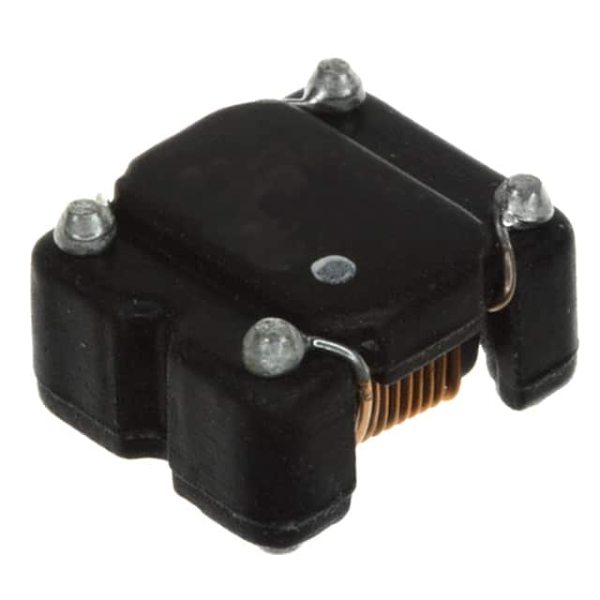 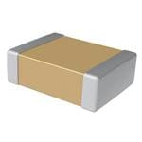

Figure 03: Passive components, CMC and ceramic capacitor for building EMI filter [8].

### Schematic Design

There are two forms of noise that may be created in a device: common mode noise and differential mode noise. An EMI filter can be used to reduce these disturbances. Ceramic capacitors and current adjusted Common Mode Chokes are among the components utilized in this filter. Common mode noise is generated due to the current flow from both line and neutral to ground [7]. Capacitors are required to dissipate common mode noise since the Common Mode Choke has a large impedance. Leakage inductance can also be generated via the Common Mode Choke. Differential noise, on the other hand, is caused by the quick change in current on the lines between line and neutral, as well as the induced leakage inductance.

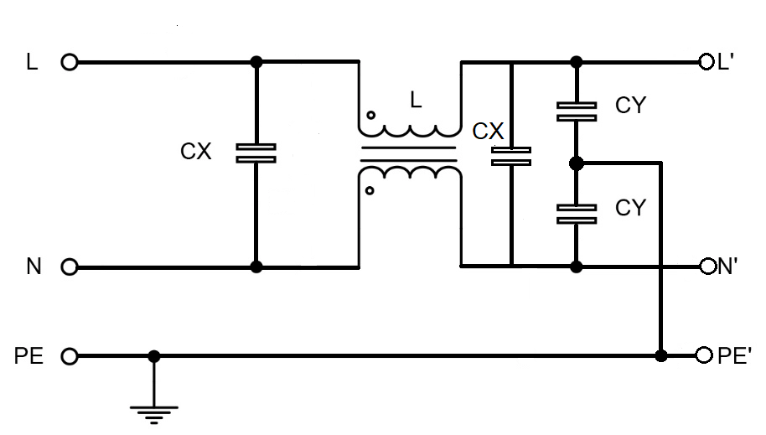

Figure 04: Standard schematic design of EMI filter [9].

In order to account for mode noise, the EMI filter is built using two distinct filters named after the produced noise. One is the Common Mode Filter, which is designed to reduce only the common mode noise, and the Differential Mode Filter, which is designed to reduce the differential mode noise. Since we are using passive elements in each of the filters, there may be very little variation in the common-mode noise or differential-mode noise and may be fluctuated due to the capacitors which are planned to use for minimising opposite mode noise.

### Common Mode Filter

In an EMI filter, a Common Mode Filter is meant by the passive element Common Mode Choke because of the generation of the magnetic flux in the opposite direction of the common mode current that produces almost zero inductance. In the following, a Common Mode Filter is shown that is designed for our purpose.

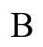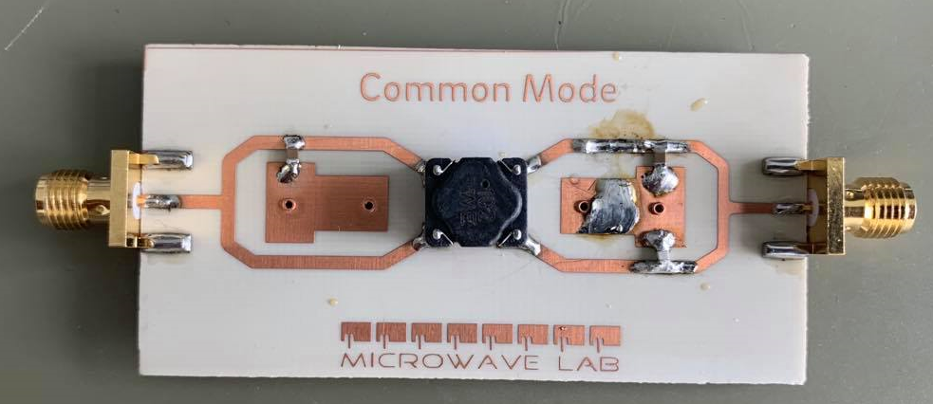

Figure 05: Hardware design of Common Mode Filter.

In the Figure 05, input signal is provided where noise is also passing with the main signal through the port A. The main signal should have filtered the common mode noise generated in the input and at the output the noise will be filtered. The amplitude will be lower than the main signal as with the current as the noise current will pass through the capacitor used as Y capacitor. The input and the output signal should have the following pattern.

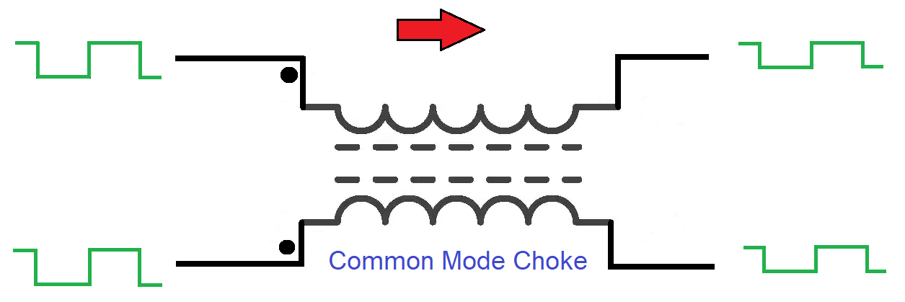

Figure 06: Expected input and output signal amplitude of a Common Mode Filter [10].

In our experiment we have got the input output signal in the Common Mode Filter but the output signal is not exactly the same in measured and simulated measurements due to the transient properties or loss due to the component I have used.

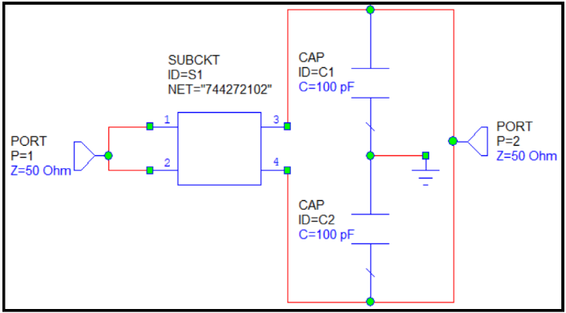

Figure 07: Common Mode Filter circuit diagram for software simulation.

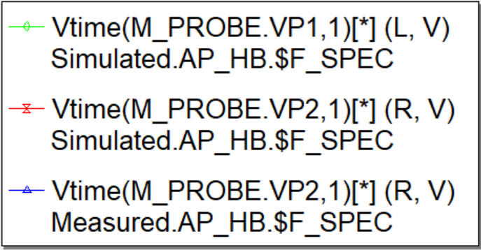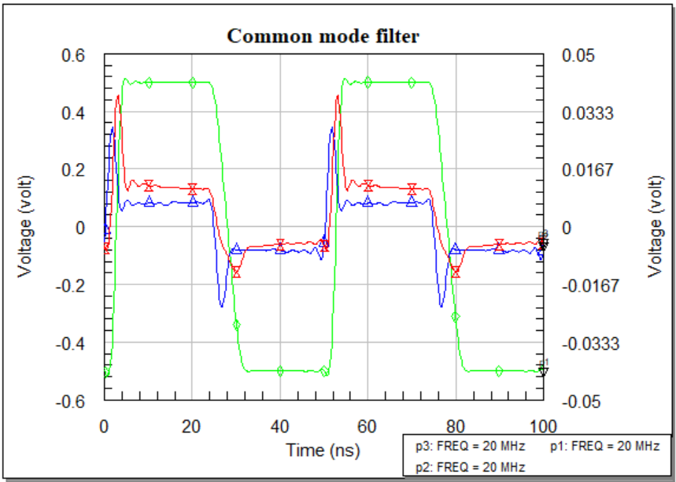

Figure 08: ‘Measured’ and ‘Simulated’ voltage measurement in time domain for square signal for Common Mode Filter.

Discussion: Figure 07 shows the schematic design of a Common Mode Filter where 100pF two capacitors have been used to reduce the common mode noise and the noise current will be transferred to ground. In Figure 08 time domain response of the Common Mode Filter where the input signal is square wave having magnitude of 1 volt and in the output signal of the measured and simulated response is very similar. There are some mismatches of these two response like in magnitudes and phases. The magnitude decreases as expectedly in the simulated result because the voltage drops in ports, transmission lines is not same in the software simulation as usually.

### Differential Mode Filter

In an EMI filter, differential noise is a major issue in case of generated conducted emissions. Differential mode noise is generated from the source in an ordinary way that is why it is called general noise. There is another source from where differential mode noise can be generated. The leakage inductance induced due to magnetic flux of the Common Mode Choke is the secondary differential mode noise. That is why there are two X capacitors are used at the two terminals of the Common Mode Choke. One will reduce the differential mode noise generated due to general current flow from the source and another one will reduce the induced current due to leakage inductance. In the following, we can understand the hardware design.

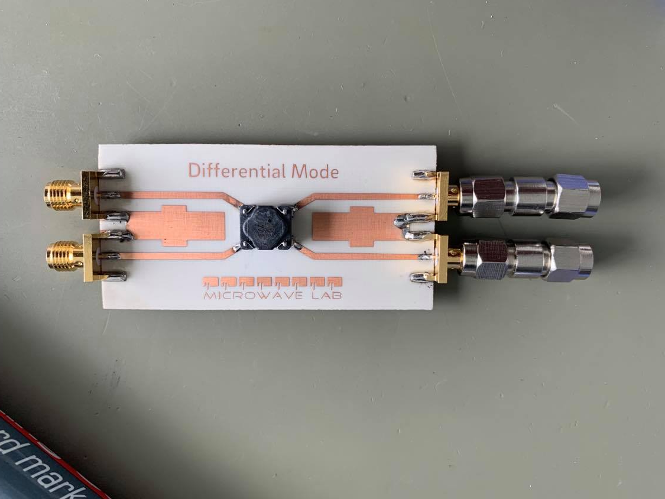 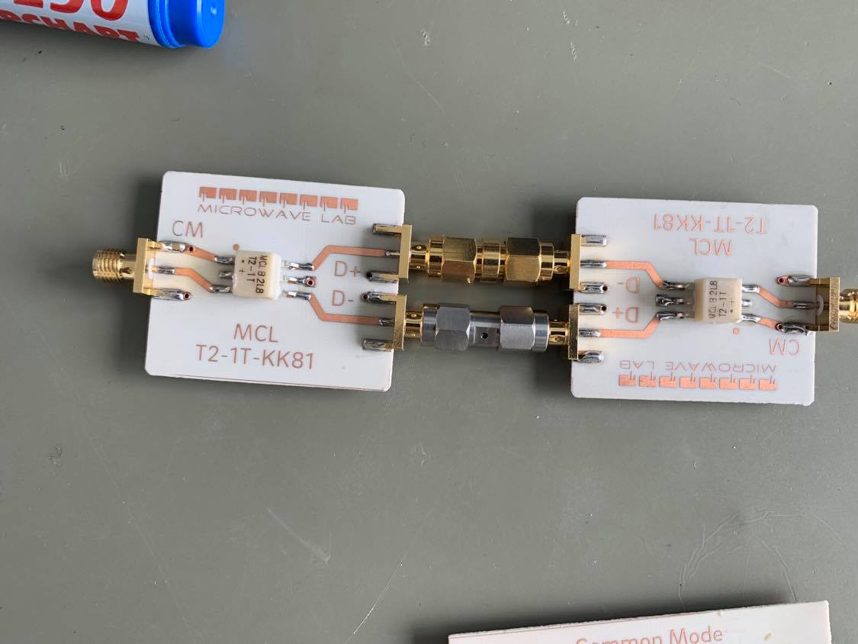

Figure 09: Hardware design of a Differential Mode Filter.

Figure 08 shows a Differential Mode Filter that will have two X capacitors. Two transformers will be installed in the both in and out terminal of the Differential Mode Filter to observe the noise and identify the magnitude as the generaded value supposed to be very small. The input and output signal in a Differential Mode Filter should be like figure 09.

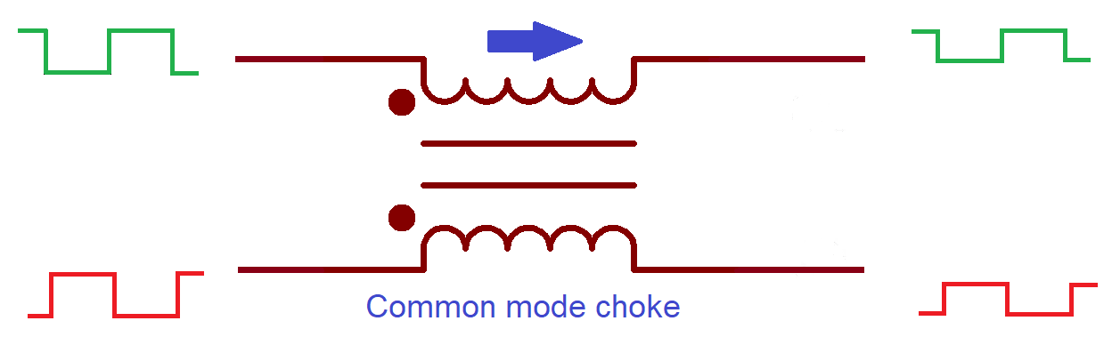

Figure 10: Expected input and output signal amplitude of a Differential Mode Filter [10].

The software implementation provides a different result for the square wave in the output side. Since we can get almost close results.

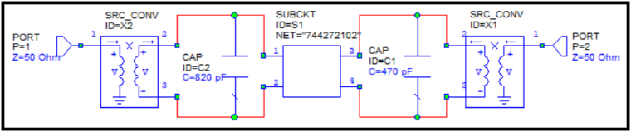

Figure 11: Differential Mode Filter circuit diagram for software implementation.

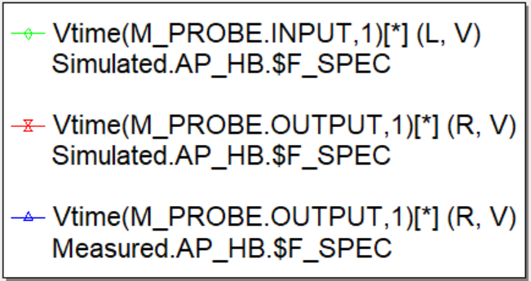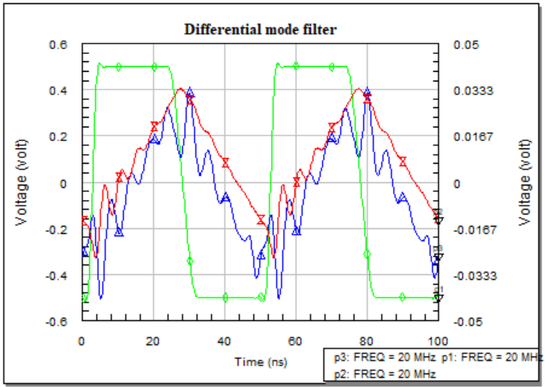

Figure 12: ‘Measured’ and ‘Simulated’ voltage measurement in time domain for square signal for Differential Mode Filter.

Discussion: Figure 11 shows the schematics design of a Differential Mode Filter where 2 transformers are also used as in the hardware design we have tested. These two transformers will be used to step up and down in the input and output voltage. We have two identical graphs of differential mode filer both for measured and simulated measurements in figure 12 where the input and output time domain response have plotted. We can observe that the output signal is in the shape of a triangle. When an input voltage across the capacitor that we have used in Differential Mode Filter, the voltage charges up exponentially. Similarly, while discharging it also discharges exponentially. Then there will be generated a parabolic exponential waveform where, the in charging side it will be the straight ascending slope and in the discharging side it will be the straight descending side. Thus these exponential waveform is converted into triangle waveform. Like the first capacitor of the filter, second capacitor will also charge and discharge exponentially and the same thing will be reaped.

### Design Flow diagram

The design flow diagram will explain the total overview of this thesis work. At the very first we have designed the standard structure of an EMI filter what we have tested a number of times that is the inductance value of the Common Mode Choke. As well as we have also checked the frequency range, rated voltage, and rated current. The ceramic capacitor also has been changed a number of times for the suitable response both in the time and frequency domain. From the footprint we designed PCB and the work stated. All the simulations have been done and a number of techniques have been followed to observe and record the output response of the filter. In this whole project, the main focus was only on the filter response and its functionality. As the whole EMI filter was partitioned into two different filters, the measurement process was a bit lengthy and complex. To observe the input and output results and compare them for a range of frequencies and doing the whole process for the different setup was a bit scattered for documentation. That is why the flow diagram is helpful to understand the whole project work.

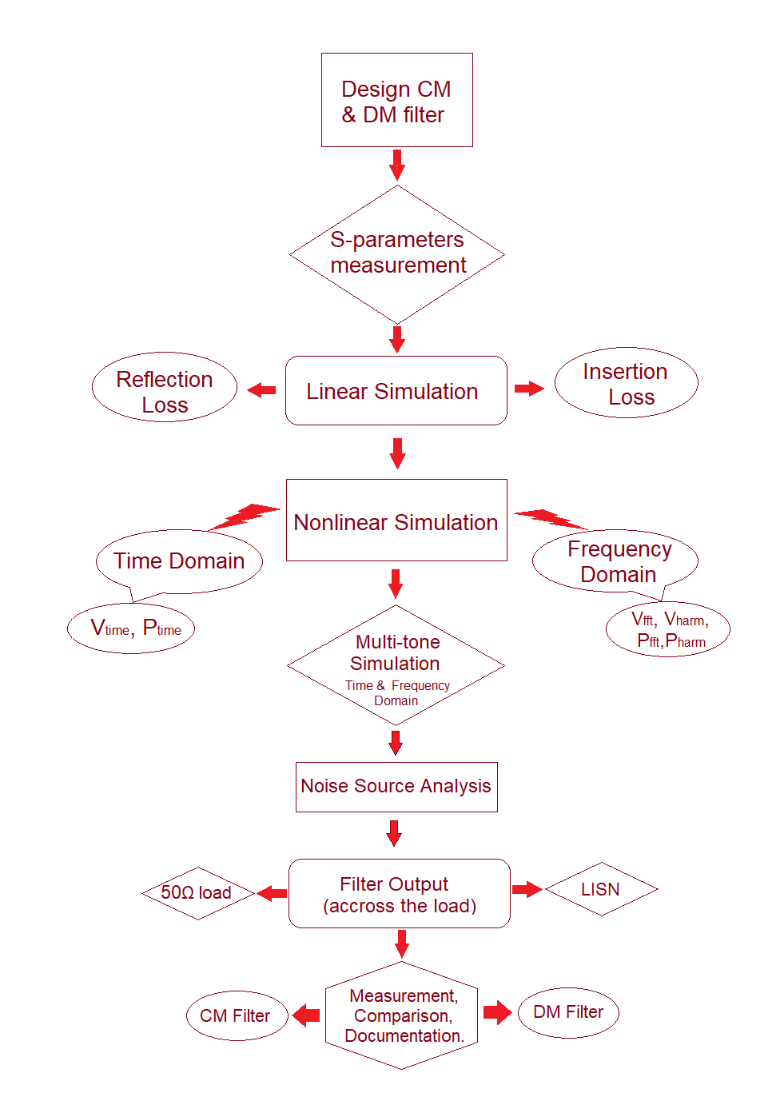

## EMI Emissions Analysis

When electromagnetic energy is produced by any source, whether unintentionally or intentionally, and released into the environment, the presence of Emission is established. EMC analysis allow for the identification of these undesirable emissions as well as the solutions that may be implemented to lessen these unwanted emissions.

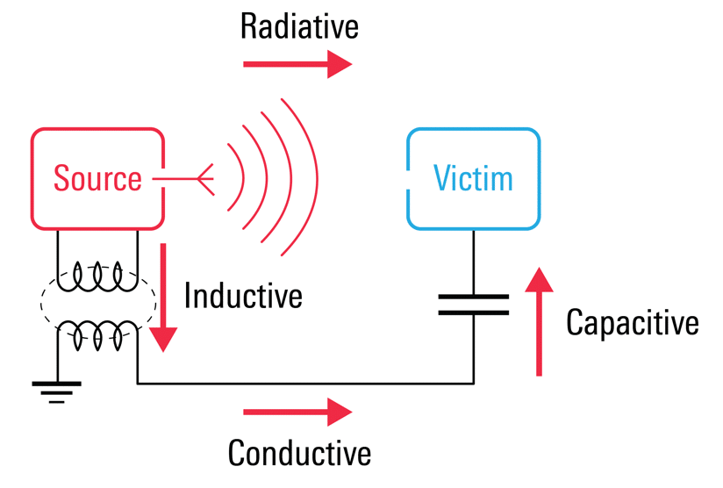

Figure 13: Induced emissions in an EMI filter [11].

### Conducted Emission

Conducted Emission is the mechanism where electromagnetic energy is created in an electronic device or sub-circuit and is transferred to another device or sub-circuit via cabling, PCB traces, power or ground planes, or capacitance [12]. This emission is capable to travels through a conductive path. This emission can be continuous or discontinuous. Continuous emissions are emitted at a given frequency but discontinuous emissions are non-constant and occur sporadically.

The conducted emission’s frequency range is 150 kHz to 30 MHz, however for individual standards, this range may be greater or lower. There are some standards that use different frequency ranges. Different value of impedances is also a concern for the manufacturers.

The three most often used standards, CISPR 11, CISPR 14–1, and CISPR 22, as well as the related EN standards, all define measurement in this frequency range. A comparable range is required by CISPR 13 (for broadcast receivers) and CISPR 15 (for lighting devices). CISPR 15 specifies a frequency range of 9 kHz to 30 MHz [12]. Conducted EMI below 9 kHz is typically classified as low frequency, whereas that between 9 kHz and 30 MHz is classified as high frequency.

### Radiated emissions

Electromagnetic energy that is generated from an electronic device intentionally or unintentionally is called radiated Emissions. Radiated emissions spread through the air from the device’s chassis. It can also radiate from interconnected cables. HDMI ports are a good example that radiate emissions. Typical magnetic field loop antennas such as the Van Veen Loop antenna measures the magnetic field emissions of a product in three-axis [13].

Circuits are filled with time-varying signals that propagate electromagnetic radiation into space. In that sense, every conductor that carries electrical currents behaves like an antenna that source energy into the surrounding and simultaneously transmits and receives radiated EMI. The CISPR22 and EN55022 standards provide a frequency range of 30 MHz–1 GHz for computers and communications-related devices [12]. For class B components the emission levels are 30 dBμV/m at 30–200 MHz but these levels may increase up to 37 dBμV/m if the frequency increases up to 1 GHz.

# Chapter Three: Filter mode

## Conducted Emission Analysis

Conducted emission is electromagnetic interference (EMI) or noise caused by the frequencies of an electronic or electrical component. These interferences are subsequently dispersed with the use of interconnecting cables. Cables include signal ports, wired ports such as telecommunication ports, and power conductors.

Conducted emissions are classified as either common mode emissions or differential mode emissions.

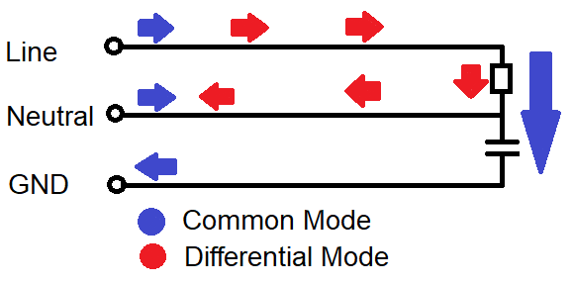

Figure 14: Conducted Emissions path in a designed device.

### Common Mode Interference

Common-mode noise is the line to ground noise generated on both sides of the AC input and in phase with its ground. It is an asymmetrical noise. The current of the common mode noise flows in the same direction through the power line and the neutral and returns through the ground conductor. The common-mode noise can be suppressed by the common-mode choke and the Y capacitors used in the EMI filter.

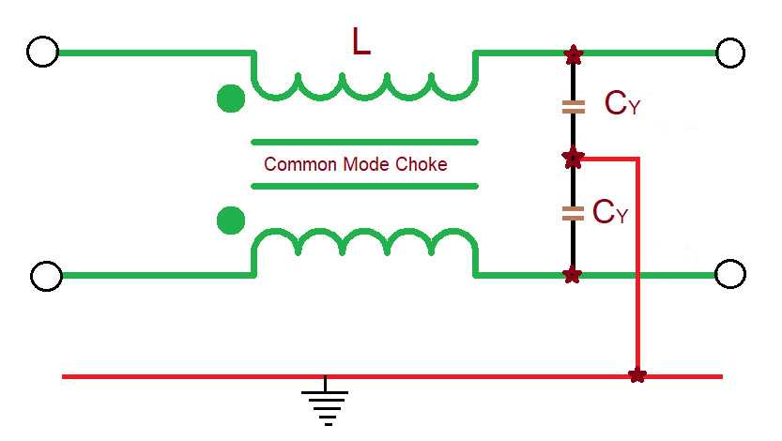

Figure 15: Common mode part in an EMI filter.

#### Common mode voltage

A common mode voltage is an uneven and unbalanced voltage. It is defined as the voltage between the conductor line and the ground, or as the mean of the phasor voltages appearing between each conductor and a specified reference, usually earth or frame [12]. If V1 and V2 are voltages on phase and neutral respectively, then the following expression gives the common mode voltage.

The voltages induced by external electric fields are generally common mode voltage ‘VCM’ given by:

VCM = (V1+V2) / 2 (1)

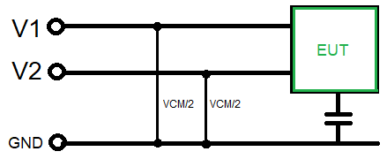

Figure 16: Voltage measurement of a Common Mode Filter.

#### Common mode current

Common mode currents are those currents that flows in the same direction on line and neutral and return via ground [12]. If I1 and I2 are currents on line and neutral, then the common mode current ICM is given by the vector sum of those two currents.

ICM = I1 + I2  (2)

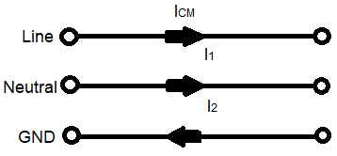

Figure 17: Current flow path in a Common Mode Filter.

#### Radiation due to Common mode noise

When the electric field intensity radiates from a system due to common-mode noise and current flow from transmitter to receiver across a specified distance, the field may be described by the equation (3). The cable length ‘L’ is a significant factor to solve the problem. 'r' denotes the distance between the observation site and the channel. It can be seen, the electric field is proportional to the length of the wire.

ECM ∝ (3)

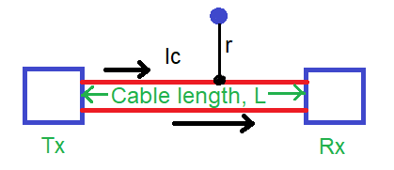

Figure 18: Common mode radiation overview.

### Differential Mode Interference

Differential mode interference is referred as the signal that is generated in between line and neutral and because of the leakage inductance of the Common Mode Choke which is generated due to short of two-port of the choke.

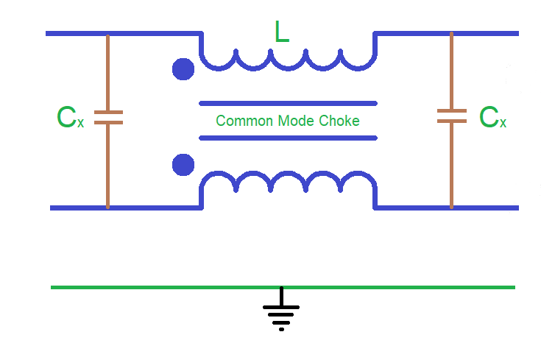

Figure 19: Differential mode part in EMI filter.

#### Differential mode voltage

Differential mode is also known as normal mode or symmetrical mode. It has a balanced voltage that is generated in between the line and neutral wires [12]. Equation (4) shows the differential mode voltage VDM. It is the difference of the voltages of line and neutral is given by:

VDM = V1 – V2  (4)

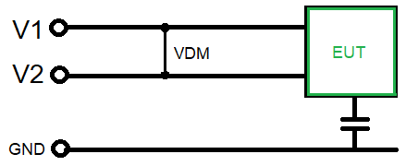

Figure 20: Voltage measurement of a Differential Mode Filter.

#### Differential mode current

Differential mode current is equal to the half of the vector difference of current that flows through line to neutral in cross-section area. In simpler terms, differential mode currents flow in opposite directions. The differential mode current is given by:

IDM = (I1 – I2) / 2 (5)

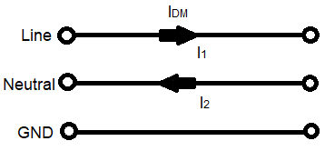

Figure 21: Current flow path in a Differential Mode Filter.

#### Radiation due to differential mode noise

Equation (6) may be used to express the electric field intensity of differential mode noise, where Id is the noise current flowing in the Differential Mode Filter. The observation point distance is ‘r’ and the noise frequency is 'f'. Differential mode noise generates a current loop, which is generally the noise current. We have considered this loop range S. From equation 6, we can see that the intensity of the electric field increases as the area of the loop increases, and vice versa, while the other elements remain constant.

EDM ∝ (6)

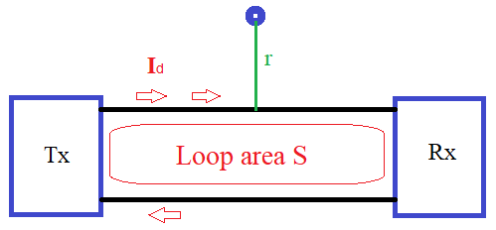

Figure 22: Differential mode radiation overview.

## Material Selection for Hardware Design

### Common Mode Choke

A Common Mode Choke is an electrical filter that is used in electronic circuits to decrease common mode noise. It filters out high-frequency noise while allowing low-frequency signals to pass through. The common mode noise (CM) emitted by sources, creates interference in electrical circuits [14]. Chokes are classified into two categories. For reducing differential mode noise, a single choke is used, while for suppressing common mode noise, a Common Mode Choke (current compensated) is applied. We used a Common Mode Choke in our project. A Common Mode Choke has more than two windings. In our case, we have used two identical windings or coils wrapped around a common core in opposite directions. The primary property is that all windings, regardless of number, are on a single core.

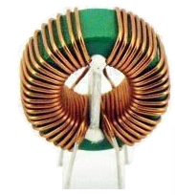

Figure 23: A Common Mode Choke [15].

The windings are interconnected around this common core. The Common Mode Choke has a common mode impedance that suppresses unwanted common mode noise. The Common Mode Choke also has some differential mode impedance, which is called leakage inductance. Most importantly, the overall distortion of the total signal due to this leakage inductance is very low because the suppression does not occur at the frequency of the transmitted signal.

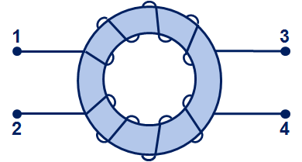 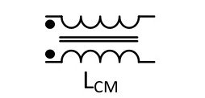

Figure 24: Physical layout and circuit schematic of a Common Mode Choke [15].

While flowing through the CMC in the same direction of the current, the two magnetic fields are generated by these directional coils add up to a large inductance or impedance, which plays an important role in suppressing common mode noise [15].

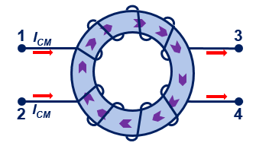 

Figure 25: Common mode current flow through Common Mode Choke [15].

When the currents flow in the opposite direction of the CMC, they produce two magnetic fields in opposite directions of the windings and cancel each other out. A very low inductance or impedance is then created in the inductor, called leakage inductance, but the core does not go into saturation even with large input currents.

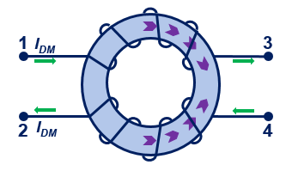

Figure 26: Differential mode current flow through Common Mode Choke [15].

A CMC is used for the filter design purpose in the circuit. It minimizes the unwanted noise travelling to the load by attenuating the energy down to a certain frequency. On that time choke produce a large inductance and then common mode noise are filtered out. But the signal induced from the choke leakage inductance also pass through the Differential Mode Filter. In the Figure 27 we have plotted measured (taken from data sheet) and simulated impedance curve and compared them.

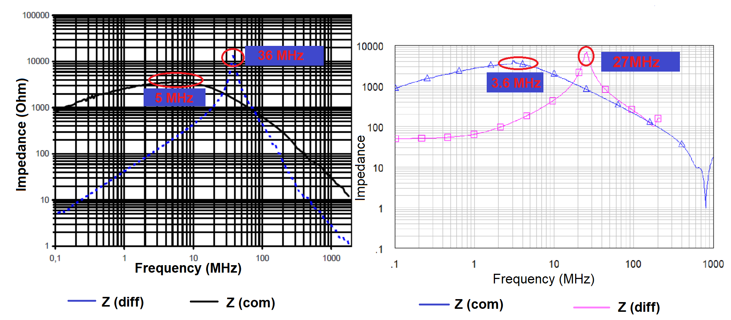

Figure 27: Impedance of a Common Mode Choke a. Measured b. Theory.

### Lumped elements

We have used two capacitors connecting between the line and the neutral wires (called X capacitor) and two capacitors connecting between the line to the ground and the neutral to the ground wires (called Y capacitor), and a Common Mode Choke to design our EMI filter. Because of the directions of noise current, CMC and Y-caps affects the common mode noise and CMC and X-caps affect the differential mode noise. When common mode noise passes through the EMI filter, the comparable Common Mode Filter suppresses it. Similarly, the Differential Mode Filter may attenuate differential mode noise. The Common Mode Filter is composed of the CMC's common mode inductance (LCM) and the parallel of CY1 and CY2 capacitors. The Differential Mode Filter, may be created using the same CMC with its leaking inductance and the CX1 and CX2 capacitors series with the CMC. In the Figure 28, it is properly indicated the alignment of the CMC and the capacitors. Although, it is a complete filter, we can design Common Mode Filter and Differential Mode Filter from it taking the components properly.

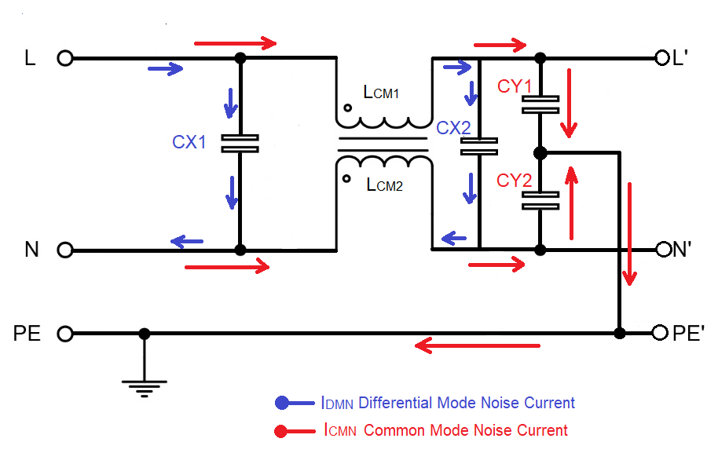

Figure 28: Lumped elements and current directions through them.

## Noise Source Design

In an electrical system, noise is an unwanted signal that may be generated during transmission, processing, reception, storage, or conversion of signals. In an electromagnetic system, noise produces harmonics that distort the main signal in order to pass it on.

In our report, we have considered a loss-pass signal generator called a comb generator. On the input side, a comb is a signal generator that generates many harmonics with comparable amplitudes. However, at the output, the spectrum analyzer displays the signal like a comb, which is why it is also called a comb generator [16]. We used a comb generator that can produce a signal frequency of up to 1 GHz in an interval of 12 MHz. That is, we get a response at 12 MHz, 36 MHz, 60 MHz, 84 MHz, 108 MHz, 132 MHz, 156 MHz, 180 MHz, 204 MHz and so on. While we get the signal response, we get harmonics at exactly 24 MHz, 48 MHz and so on.

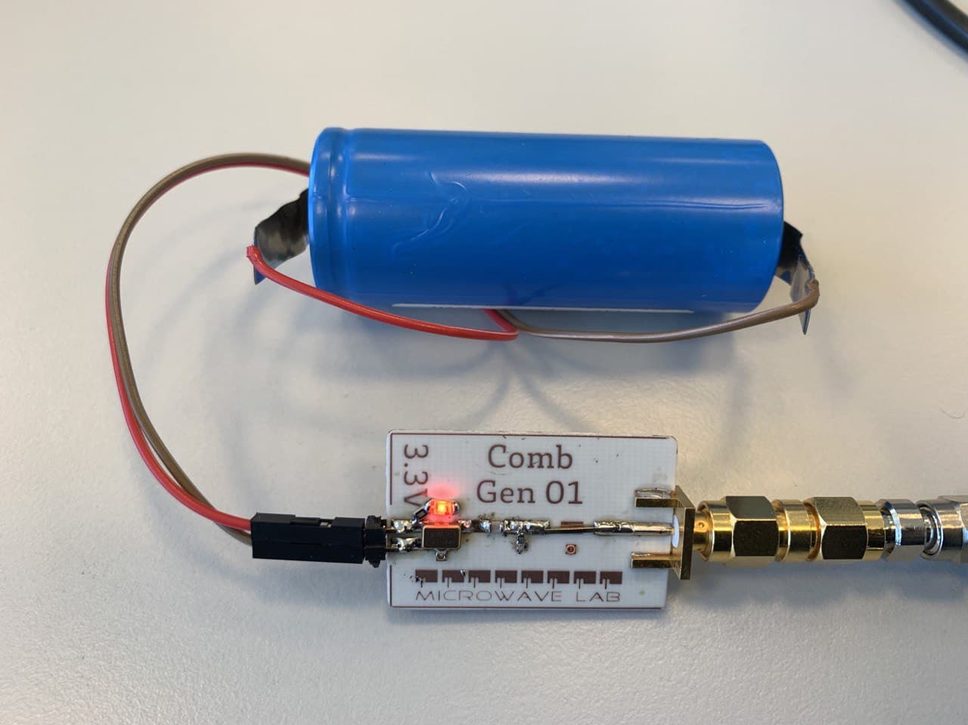

Figure 29: Noise signal generator (Comb generator), physical and circuit layout.



Figure 30: Hardware design of a Comb generator and the input power with frequency.

Discussion: As the magnitude of the comb generator should have the same power for the overall harmonics but here we have got variations in power for different frequencies. These differences in power, however, have no influence on our measurement.

## Line Impedance Stabilization Network (LISN)

LISN is used to measure how strong the radio transmitter is when the RF emissions enter through the power lines. LISN ensures that the power supply to the device under test is not interrupted and passes all emissions to the resistive load. The spectrum analyzer makes the measurement that the load receives.

LISN is designed to provide constant line impedance over a range of frequencies. It also minimizes the measured noise generated by the EUT. If we want to measure the performance of the LISN, it is important to know how much the external RF emission is attenuated by the LISN from the power supply and how much it is attenuated from the test device to the device to be measured [17].

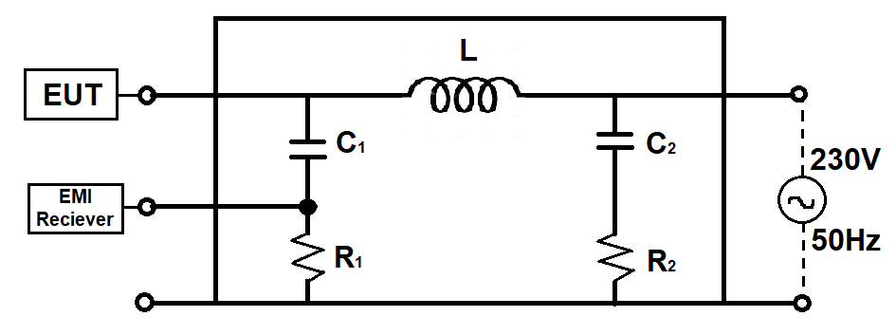

Figure 31: Circuit diagram of LISN.

# Chapter Four: Filter Behaviour Prediction

## Linear Simulation

### S-parameter measurement

S-parameters are divided into two major categories:

* Two-port networks,
* Reflections on transmission lines.

#### Two-port network

It is the most commonly used circuit analysis technique that provides an equivalent circuit model for the specified terminal pairs of the network. The basic principle of two-port network analysis is to calculate only the terminal variables (input voltage, input current and output voltage, output current) instead of calculating the voltages and currents of all points within the circuit [18]. Two-port network analysis in EMC estimates the voltages and currents in sinusoids at each frequency based on their amplitudes and phases.

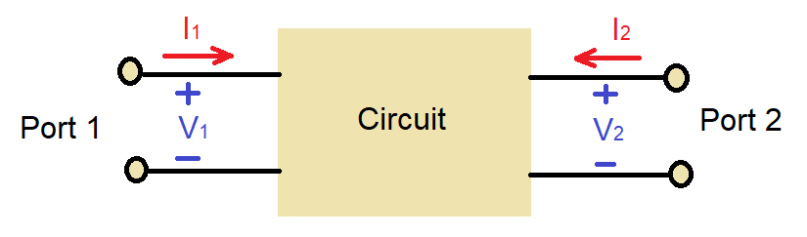

Figure 32: Two port network diagram.

In a two-port S-parameters we can get four individual parameters which are:

S11 is the input voltage reflection coefficient

S12 is the reverse voltage gain

S21 is the forward voltage gain

S22 is the output voltage reflection coefficient.

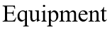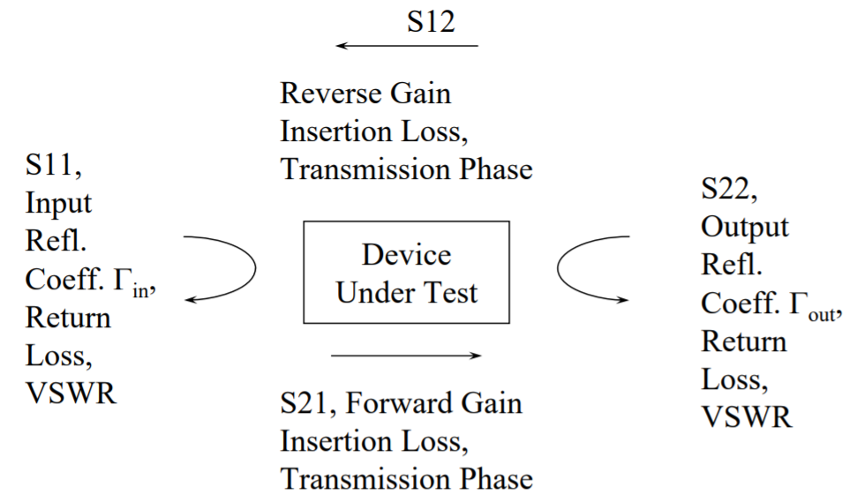

Figure 33: Definitions of four individual S-parameters.

To design and simulate an EMI filter connected to a noise generator, we performed a linear simulation. This linear simulation includes finding the S-parameters of the Common Mode Choke and capacitors. We also had to measure the S-parameters of the Common Mode Filter and the Differential Mode Filter. We have used a vector network analyzer to measure all these parameters.

The measured S-parameters of the designed Common Mode Filter and Differential Mode Filter are shown in the Figure 33. Comparison between the Common Mode Filter and the Differential Mode Filter in the Software and the Hardware simulation are countable.

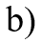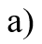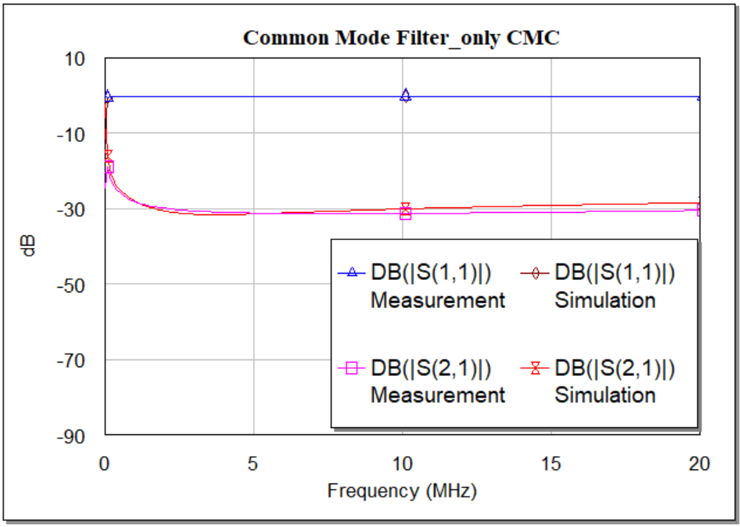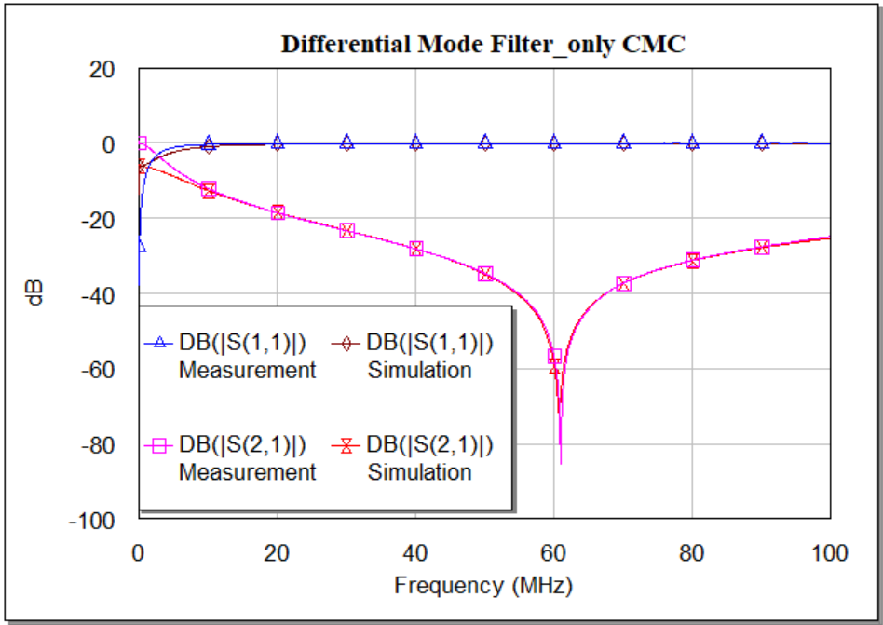

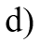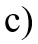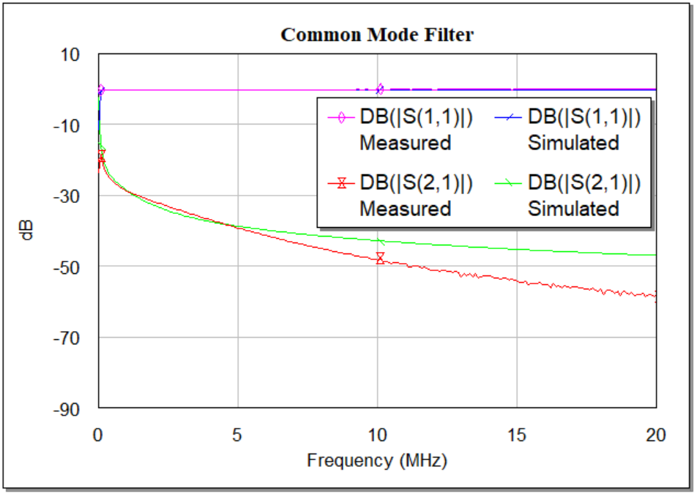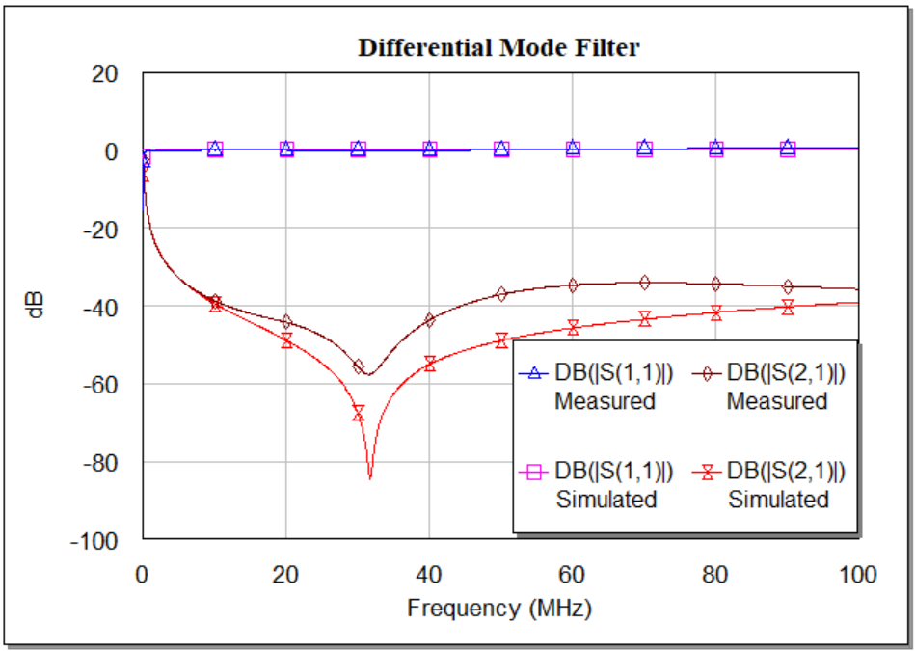

Figure 34: S-parameters measurements of, a) CMF, b) DMF only with Common Mode Choke; Comparison between measured and simulated measurements in dB for c) CMF, d) DMF (complete filter).

Discussion: Determination of S-parameters is an important part of RF measurements. In the software simulation when we measure some response of a device then will definitely get some variations with the hardware measurements. For designing a Common Mode Filter and a Differential Mode Filter we have simulated in software. We have designed these filters using Common Mode Choke and capacitors. There are some basic reasons for the variations of measured and simulated results. One of the basic reason is capacitance. As we know every single components has its own capacitance whatever it is SMA connector or other components we have used in designing the filter. For the Differential Mode Filter, the resonance frequency of the filter has is decreased from 61MHz to 31MHz due to the use of ceramic capacitors. Another reason is resistivity. In the software simulation, some values have changed due to the port resistance. In Figure 34, we have measured the overall S-parameters of the Common Mode Filter and Differential Mode Filter we have designed in the hardware platform. Figure 34 a) and b) are those two filter having only Common Mode Choke. As we know Common Mode Choke is designed to minimise the common mode noise and partial differential mode noise due to induced leakage inductance. Figure 34 c) shows a proper Common Mode Filter having the nice shape of response both hardware and software platform. Although, in practical the insertion loss is higher. Figure 34 d) represents the Differential Mode Filter in both platform and here after 7 MHz the transition occurs.

**Transfer function analysis**

A filter’s behaviour can easily estimate using the transfer function. It determines how an output signal relates to the input signal at a given frequency. An EMI filter allows low-frequency AC signals to flow through the circuit. The frequency of the input signal is proportional to the frequency of the filter's output signal. A variety of components are utilized to build filter circuits with varying properties. The transfer function can be obtained from a graph of the output signal at various frequencies and also can be computed using Kirchhoff's principles [19].

$H\left(f\right)=\frac{V_{out}\left(f\right)}{V_{in}\left(f\right)}; \left|H\left(f\right)\right|= \left|\frac{V_{out}\left(f\right)}{V_{in}\left(f\right)}\right|; θ=arg H\left(f\right)$ (7)

The voltage and current of the input and output can be measured using the S-parameters. However, a different parameter analysis is used for this purpose, which is called the ABCD parameter matrix. During a signal transmission, many losses can occur in the transmission line which reduce the efficiency of the line. The conversion of S- parameters to ABCD parameters can be done using equation 8, equation 9, equation 10 and equation 11.

A = $\frac{\left(1+S_{11}\right)\left(1-S_{22}\right)+S_{12}S_{21}}{2S_{21}}$ (8)

B = $Z_{0}\frac{\left(1+S_{11}\right)\left(1+S_{22}\right)-S_{12}S_{21}}{2S_{21}}$ (9)

C = $\frac{1}{Z_{0}}\frac{\left(1-S_{11}\right)\left(1-S_{22}\right)-S_{12}S_{21}}{2S_{21}}$ (10)

D = $\frac{\left(1-S_{11}\right)\left(1+S_{22}\right)+S_{12}S_{21}}{2S_{21}}$ (11)

As all the S-parameters are set of data in phasor form, so ultimately we will obtain ABCD matrix in phasor form also. Here Z0 is called the line impedance which is considered as 50Ω. The following formulae can be used to compute voltage and current:

(12)

So, V1 = AV2 + BI2 (13)

I1 = CV2 + DI2 (14)

When a signal travels through a filter, the output signal is phase shifted in comparison to the input signal. This indicates that a transfer function is a complicated frequency function. It provides all of the information needed to calculate the amplitude and phase of the output signal. Using the ABCD parameter, we can simply compute the transfer function. The S- parameter may be used to compute the ABCD matrix. So, we can use Equation 15 to determine the transfer function from the ABCD parameters, where the source and load impedances are both 50.

$H\left(f\right)=\frac{V_{out}\left(f\right)}{V_{in}\left(f\right)}=\frac{Z_{L}}{AZ_{L}+B+CZ_{S}Z_{L}+DZ_{S}}$ (15)

Since ABCD parameters are complex values that change with frequency, the transfer function will have a complex phase and magnitude as well. We can obtain the value of the ABCD parameter by putting the values of ZL and ZS together [19]. As S-parameters are complex, so we have used MATLAB to plot the transfer function.

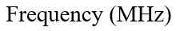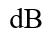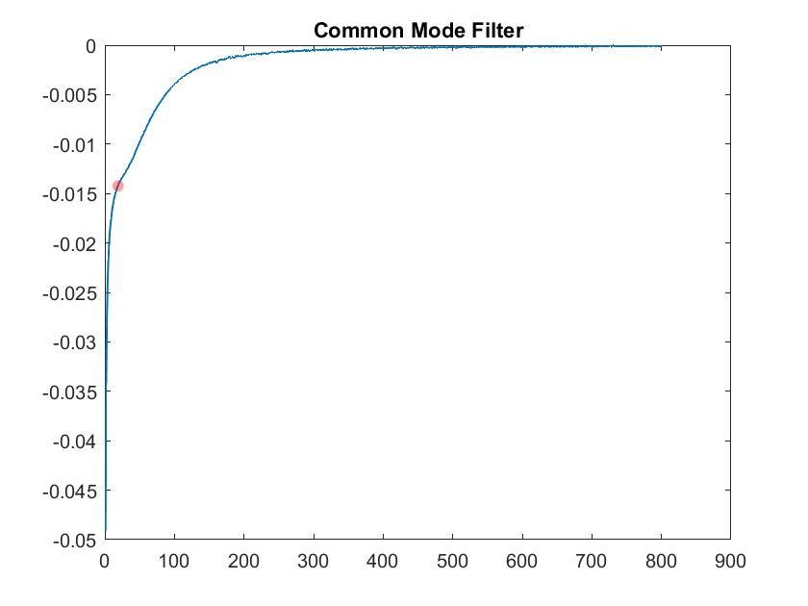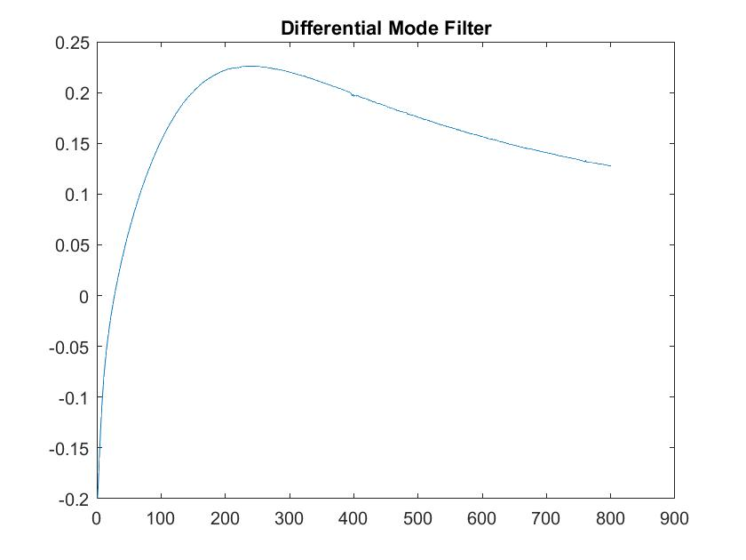



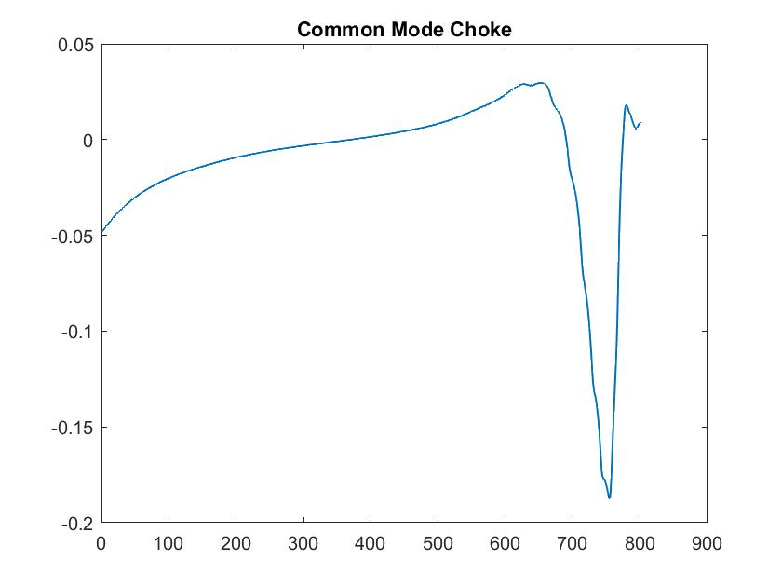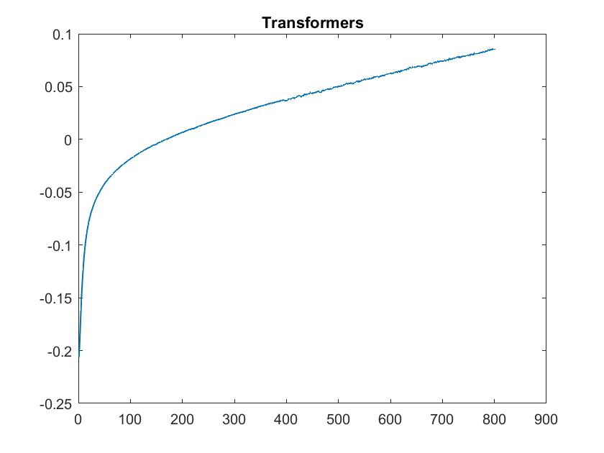

Figure 35: Transfer functions of a) Common Mode Filter, b) Differential Mode Filter, c) Common Mode Choke, d) transformers.

Discussion: In Figure 34, we have got the transfer function of the Common Mode Filter and Differential Mode Filter. As well as the transformer that we are using alone with the Differential Mode Filter. We have completed this simulation using hardware measured data. That is why we have got some mismatches for both Common Mode Filter and Common Mode Choke. As we have seen in the Figure 35, the transfer function is raised over 0dB due to negative resistance after 300 MHz. So, after this frequency we have ignored the measurements.

### Reflections on transmission lines

A two-port network is referred to as a system network that has two input ports and two output ports. Two input ports are connected to the source and the other two are connected to a load of the circuit. These input and output ports are balanced, so if you swap the input and output ports, the overall transmission characteristics will not change. The transmission line depends on the dimensions, thickness, and spacing of the components, which must be very accurate, and the impedance matching must also be correct to minimize the transmitted and reflected power loss. In a RF system, the transmission line losses can be specified by calculating the S-parameters of the whole network. The S-parameters are mainly influenced by the characteristic impedance ZC of the network and the propagation constant 𝛾 [20].

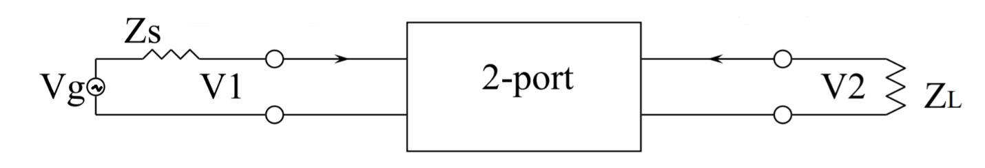

Figure 36: Transmission line of a two-port network [20].

The interchanging of these two-port cannot change the transmission line S-parameters except these three factors:

* Frequency
* Characteristic impedance
* Line geometry

The characteristic impedance ZC and the propagation constant 𝛾 can be calculate by equation 16 and equation (17).

$Z_{C}= \sqrt{\frac{R+jωL}{G+jωC}}$ (16)

$γ=\sqrt{(R+jωL)(G+jωC)}$ (17)

Here, R, L, G, and C all are the distributed elements of the transmission line.

#### Insertion Loss Measurement

On its way down a transmission line to a component or circuit, a signal loses some power due to noise or component limitations. When the RF signal is transmitted from one port to another port, the total power loss is called insertion loss.

Insertion loss is the ratio between the output power and the input power [21]. It is measured in decibels (dB). The formula for determining insertion loss is as follows:

Insertion Loss = 10 $\log_{10}\left[\frac{P_{out}}{P_{in}}\right] dB$ (18)

Insertion loss can be measured using the S parameter. It is denoted by S21. Equation (18) can thus also be written in terms of the S parameter as follows:

Insertion Loss = -20 $\log_{10}\left|S_{21}\right| dB$ (19)

The insertion loss of the common-mode filter and the push-pull filter (ILDM and ILCM) can be determined by subtracting the emission limit from the measured DM and CM noise levels without filter.

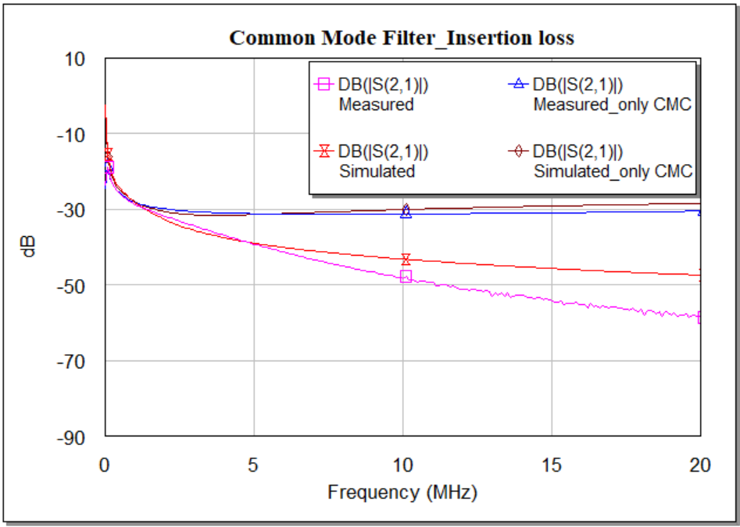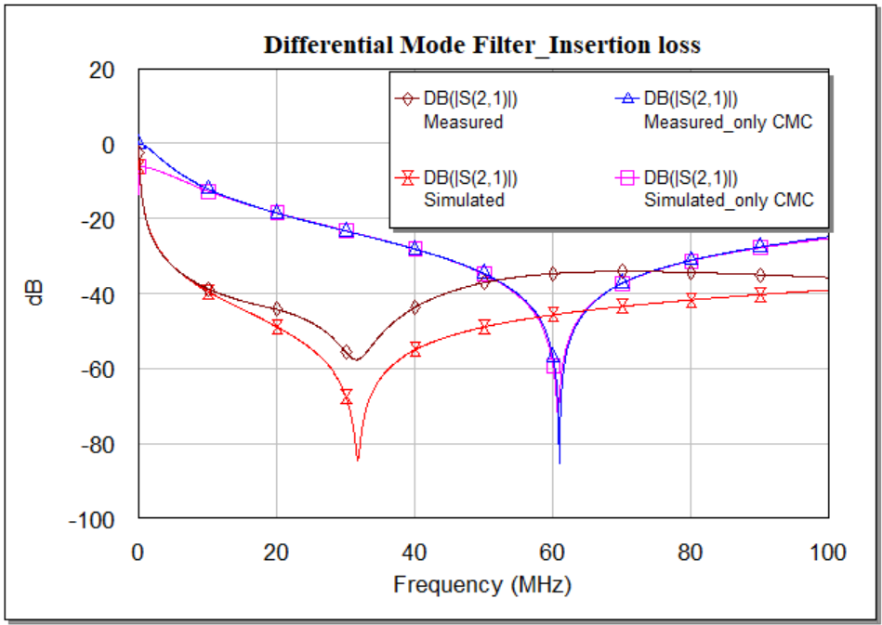

Figure 37: Insertion loss measurement of CM and DM filter in Hardware (measured) and Software (simulated) platform.

Discussion: Insertion loss for both Common Mode Filter and Differential Mode Filters are plotted in Figure 37. The insertion loss for the Differential Mode Filter in the hardware measurement, the resonance frequency sifted to the higher frequency because of the value tolerance (±10%) of the ceramic capacitor and parasitic effect of the different connections. For a certain frequency the insertion loss for the Common Mode Filter is higher than the Differential Mode Filter. For the Common Mode Filter, the amount of loss is quite similar till 5MHz. After that, the loss is higher in hardware.

#### Reflection Loss Measurement

When a generated signal is to be passed through a transmission line, some of the energy is reflected back to the source. This lost energy is called reflection loss. Reflection loss can occur due to an impedance mismatch of the input and output signals. Sometimes this mismatch occurs only in the cables if they are damaged or spliced. When this loss is higher, a very small amount of energy is transmitted. A high reflection loss sometimes damages internal components.

Figure 40 shows how a forwarded power Pfwd is partially reflected to the load as Pload and partially reflected to the source as Pref.

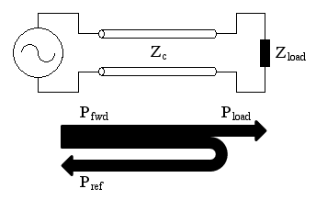

Figure 38: Power is reflecting to the source [22].

We can measure the reflection loss in terms of signal power if we know the forward power or incident power (Pincident / Pfwd) and the reflected power (Pref).

Reflection Loss = 10 $\log_{10}\left[\frac{P_{reflected}}{P_{incident}}\right]dB$ (20)

From the S-parameters we can easily calculate reflection loss.

Reflection Loss = $\left|S_{11}\right|$

There is a difference between return loss (RL) and the reflection coefficient ${ S}_{11}$. RL in dB is 10 $\log_{10}\left[\frac{P_{incident}}{P_{reflected}}\right]$. So the relation between return loss and reflection loss is,

Reflection Loss (dB) = - Return loss (dB)

In our EMI filter design work we have measured reflection loss both of the Common Mode Filter and Differential Mode Filter in hardware and software platforms on dB scale.

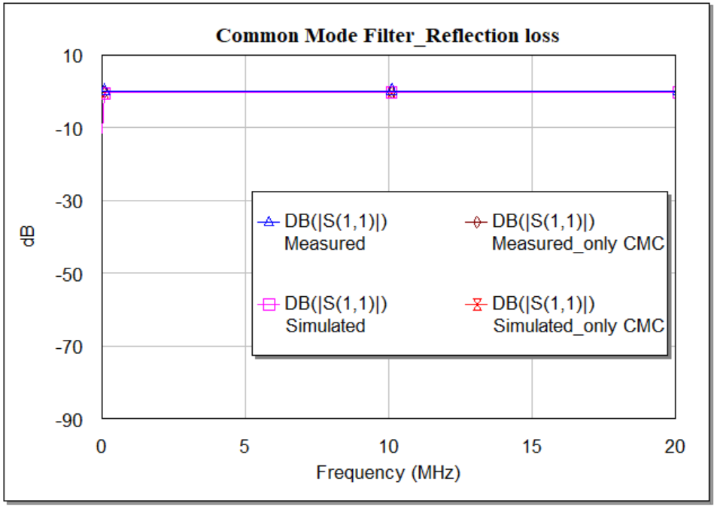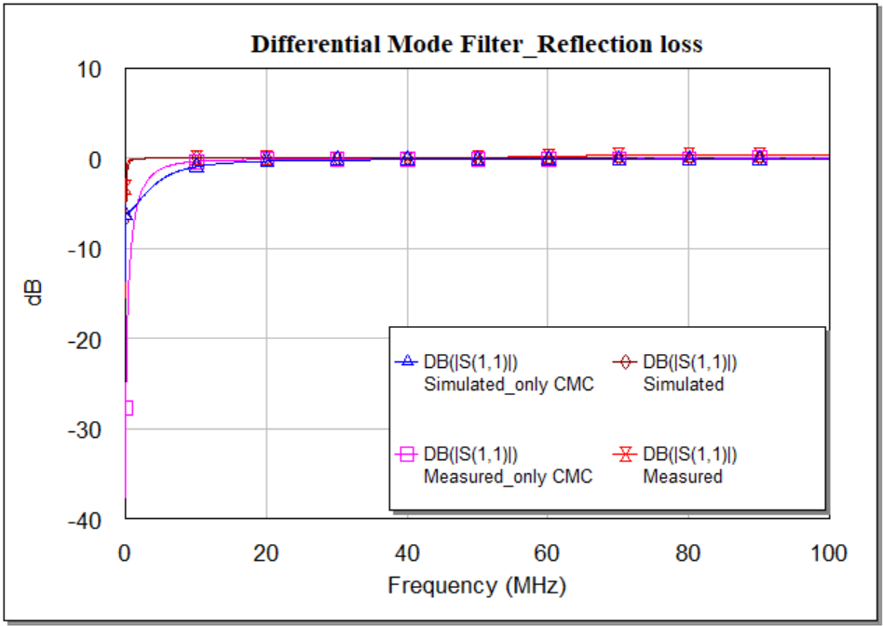

Figure 39: Reflection loss of Common Mode Filter and Differential Mode Filter.

Discussion: There are some reflection losses in the Differential Mode Filter due to the signal nature and as currents generates in between the line and neutral, some noise current might be stored in the ceramic capacitor we are using before the CMC, may reflect to the source. But for the Common Mode Filter filter, the reflection loss is nearly zero. In Figure 39, the reflection loss for both of the filters is given in hardware and software platforms and the amount of loss is almost same in both platforms.

## Nonlinear Behaviour

A continuous signal can be represented in both the time and frequency domains. When this type of signal manage to operate a device into its nonlinear domain, the shape of the waveform becomes distorted. This behaviour varies depending on the domain. This distortion is induced by a shift in harmonics in the frequency domain. It is identified by the responses of the equipment under test (EUT). This EUT is inspired by a series of discrete tones which are relatively small. For this reason, the principle of superposition of harmonics can be correctly applied.

### Harmonic Balance Techniques

The Harmonic Balance (HB) algorithm is very widely used to solve nonlinear networks. The HB algorithm divides the main circuit into two sub-circuits, a linear sub-circuit and a nonlinear sub-circuit. It is also known as the frequency domain approach for determining steady-state response. When a sinusoidal signal is applied to a nonlinear component in the system, this signal produces harmonics of the fundamental frequency in a certain range [23]. The fundamental simulation frequency (known as the input tone) is used to determine the number of harmonics required to accurately represent the nonlinear distortion. For a solver with one tone HB, analysis are only performed for a single frequency, such as Vin/Vout, Pin/Pout. For multiple tones, the analysis may include intermodulation distortion. Once the number of tones is defined, the HB solver divides the circuit into two subgroups, one is linear and another one is nonlinear, and proposes a set of voltages at the intersection of these subgroups which can be defined in the frequency domain. These voltages are then transferred to the time domain in nonlinear models and converted again to the frequency domain. If the simulation is to be performed over a frequency range, the sources should be updated accordingly and the algorithm repeated until the frequency set is covered.

### Time-Domain Analysis

The best way to find out how a filter will work is to simulate it in the time domain. This is a recently proposed technique that represents the response and simulates waveforms in the time domain. This technique is essential to determine signal distortion due to the nonlinearity of the device. With the help of fast Fourier transform (FFT) the time domain solutions can be converted to the frequency domain solutions [24].

#### Voltage analysis

The best way to find out how a filter will work is to simulate it in the time domain. This is a recently proposed technique that represents the response and simulates waveforms in the time domain. This technique is essential to determine signal distortion due to the nonlinearity of the device. According to the continuity equation, the nonlinear currents are equal to the linear currents. The repeated equalization of the currents between the linear and nonlinear network nodes can drag out the simulation time, and sometimes it fails to converge.

Since the whole filter is divided into two parts according to the noise level, each measurement is divided systematically.

##### Common Mode measurement

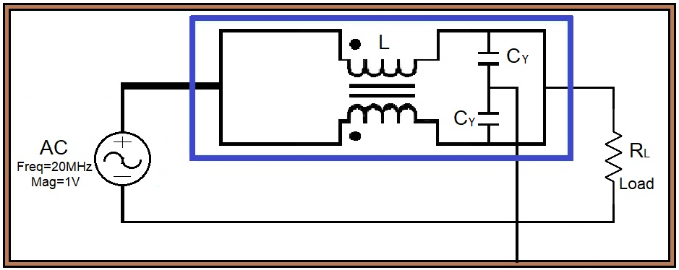

Figure 40: Circuit design of CMF voltage measurement in time domain.

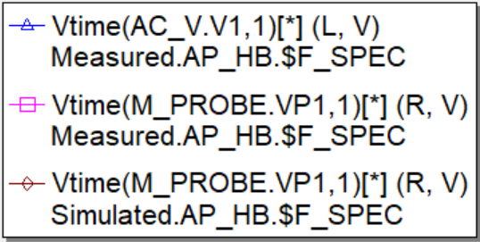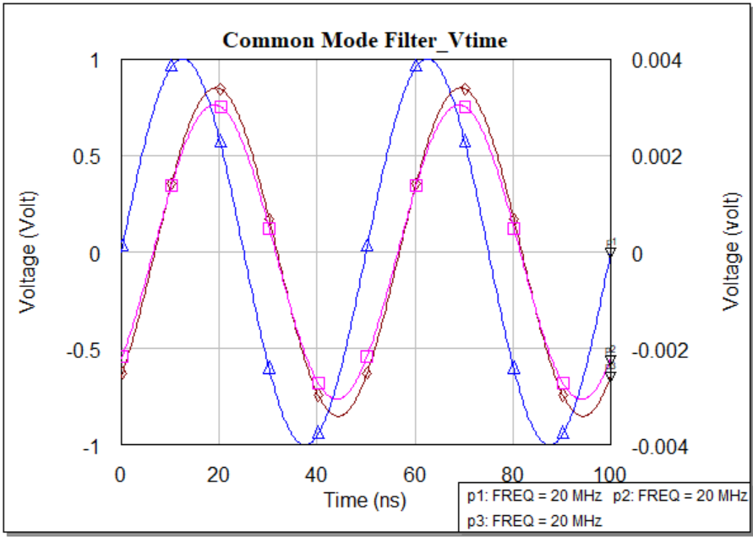

Figure 41: CMF voltage measurement in time domain using sinusoidal signal.

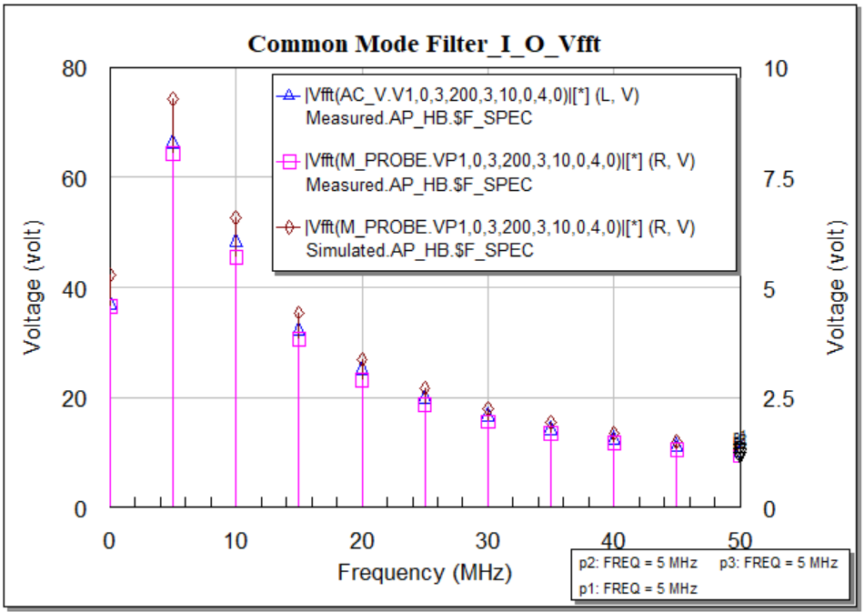

Figure 42: CMF voltage measurement in Frequency domain using sinusoidal signal.

Discussion: According to the basic structure of a Common Mode Filter, the signal is passing through both line and neutral. Due to the Common Mode Choke the voltage is decreasing and at the output, we are getting lower voltage. In the Figure 40, we have designed a Common Mode Filter with the specific magnitude and frequency. Figure 41 shows the sinusoidal input and output of measured and simulated filter. This simulation results shows the matches of those measurements. We can easily observe the result in FFT domain simulation and with the increasing of the frequency the values are decreasing. Again in Figure 42 we also get the simulation in frequency domain.

##### Differential mode measurement

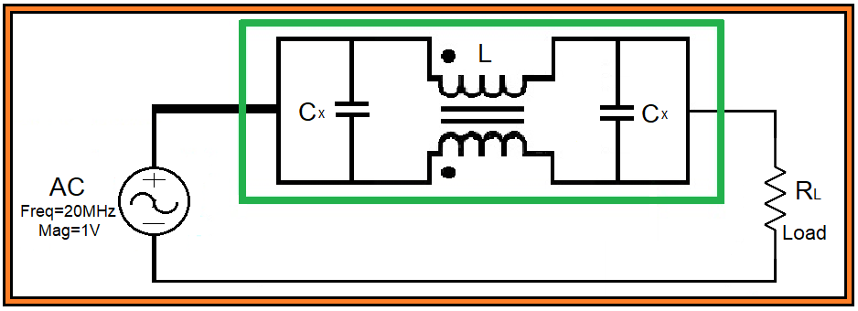

Figure 43: Circuit design of DMF voltage measurement in time domain.

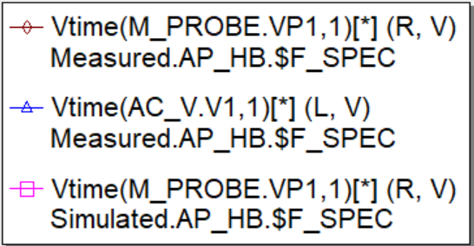 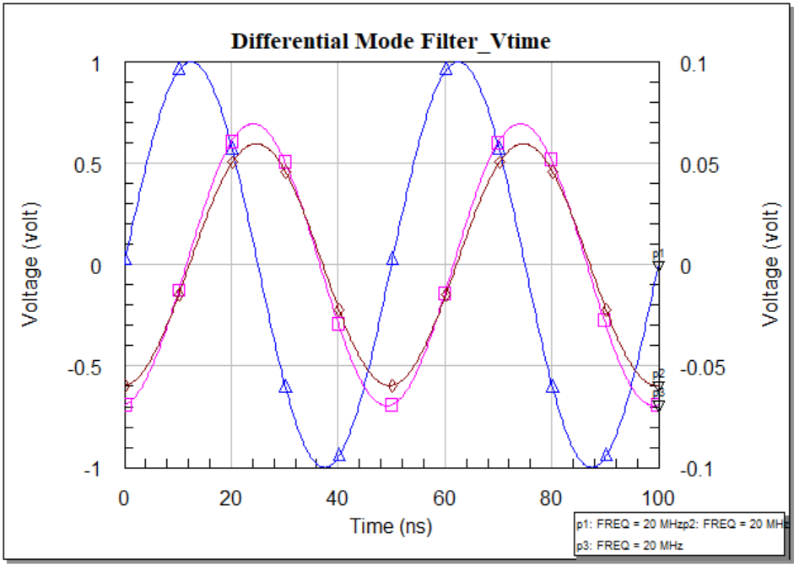

Figure 44: DMF voltage measurement in time domain using sinusoidal signal.

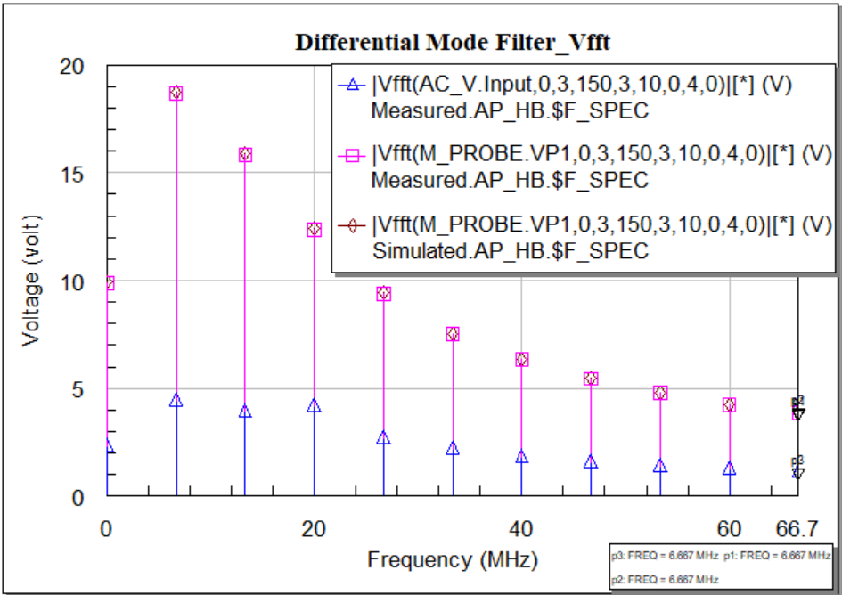

Figure 45: DMF voltage measurement in Frequency domain using sinusoidal signal.

Discussion: Differential mode noise is generated due to the source and leakage inductance of Common Mode Choke. Figure 43 shows the circuit block diagram of a Differential Mode Filter. In the next Figure 44, we get the sinusoidal input and output. Here we also get the similarities between measured and simulated measurements. As usually we have also measured the voltage output in frequency domain in Figure 45.

#### Multi-tone Analysis

Multi-tone analysis is an advanced technique commonly used to test electronic devices, whether passive or active. In this paper, we have applied this test to a linear device such as an electromagnetic interference (EMI) filter. Multi-tone testing uses multiple tones to test the equipment under test (EUT) and this technique is more efficient compared to single tone and two tone testing [25]. This test involves the generation of multi-tone signals consisting of a summation of sine waves. These sine waves are different from the waves of the input signal. Only devices that meet the specification of the crest factor (CF), which is the ratio between the peak amplitude of the waveform and the value RMS.

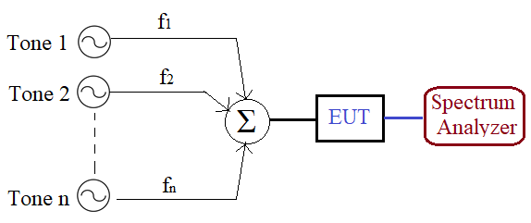

Figure 46: Multi-tone measurement process.

A sinusoidal signal’s amplitude and phase change are not considered as distortion. However, a complex, time-varying signal can drastically change amplitude and phase shift, distorting the waveform in the time domain. In a nonlinear device, the input signal can be shifted in the frequency domain and produce a new output signal in the form of harmonics. For the test, we used three sinusoidal signals as input signal. It is easy to see that the output signal is generated in the form of harmonics with different order [26].

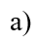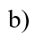 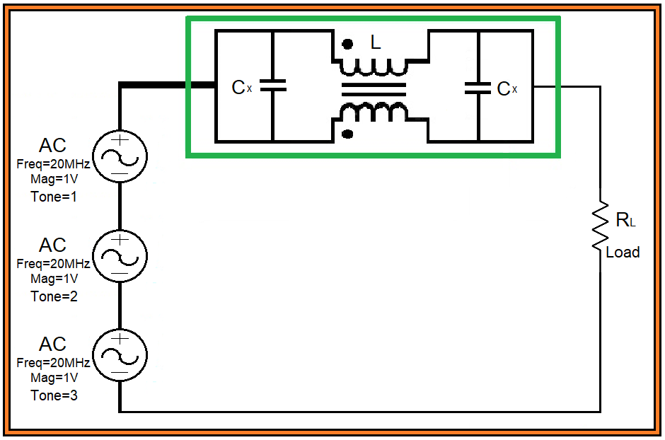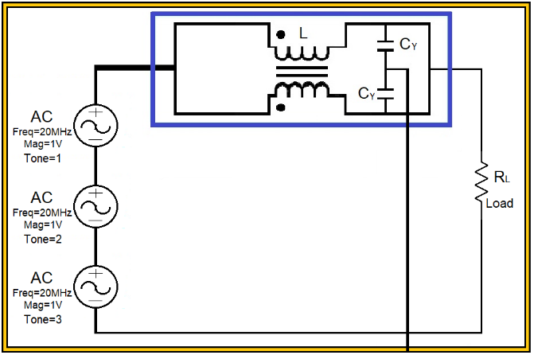

Figure 47: Circuit design of a) CM and b) DM filter with multi-tone signal source.

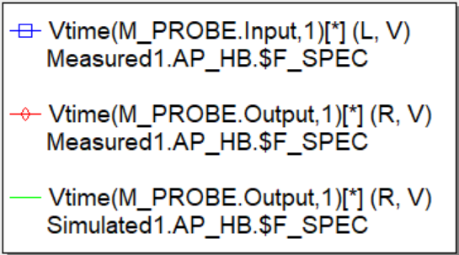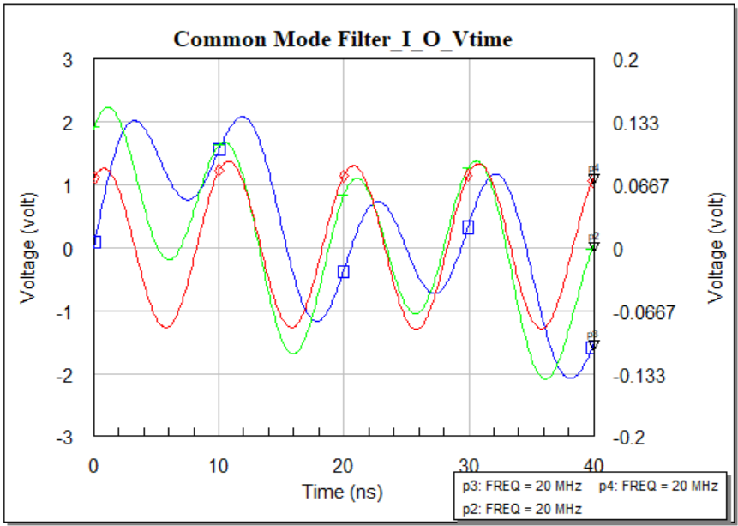

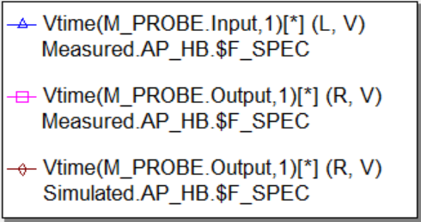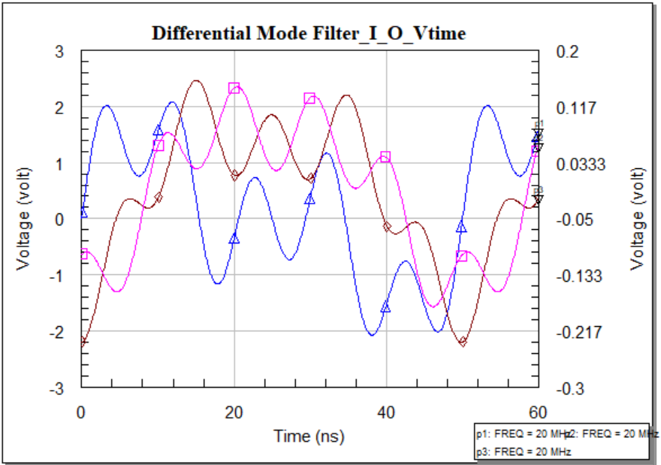

Figure 48: Voltage analysis of CMF and DMF for multi-tone input signal in time domain.

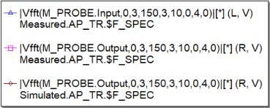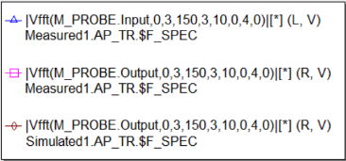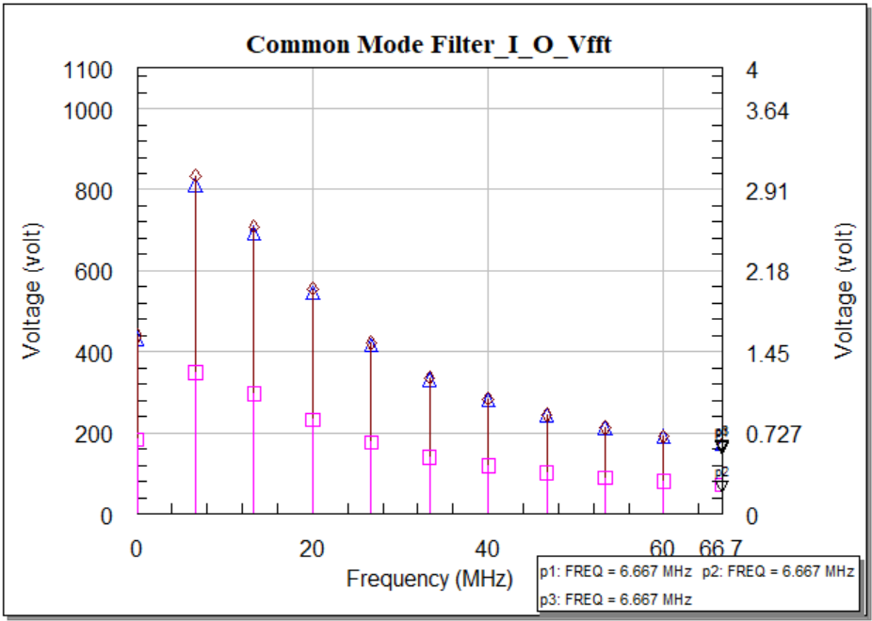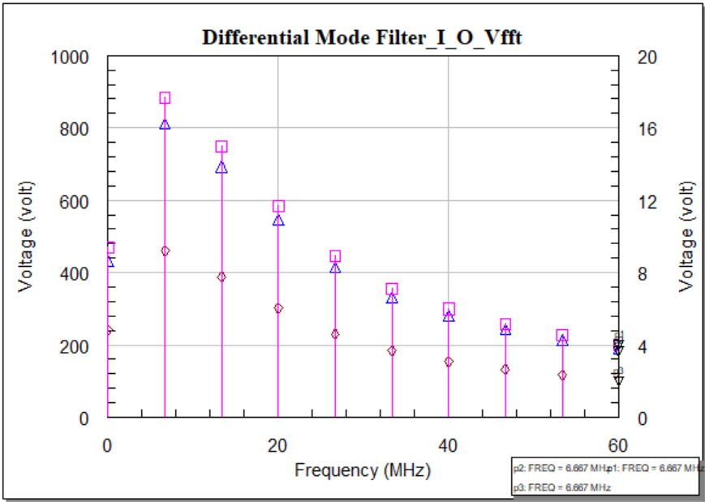

Figure 49: Voltage analysis of CMF and DMF for multi-tone input signal in frequency domain.

Discussion: A multi-tone signal means multiple sinusoidal signals having individual tones. In Figure 47 we have designed a filter with multi-tone signal. Figure 48 says, the magnitude and the phase of the measured and simulated output are not quite similar or same in the time domain measurement. These variation is not considered as distortion always. The level of variations is different in both of the filter. In Common Mode Filter, this variations remain limited within phase and negligible in magnitude but for the Differential Mode Filter, this variations is visible both in phase and magnitude. In frequency domain, the voltage analysis is plotted in Figure 49. Frequency domain means the response that we have got in the time domain, converts to fast furrier transform. For that reason, we will only get responses at the frequency that is set for each tone individually. The magnitude will vary as it varied in the time domain.

#### Power analysis

Analyzing the power consumption is the vital part of a nonlinear simulation. That is why it is very important to identify the best way to minimize power consumption in an electric circuit. In this paper as we have tried to observe the power consumption in our designed filters both in hardware and software platform. To understand this overall process we have used two set of capacitors and among them one set we have used according to available filter in the market and another set were chosen for comparing the effects.

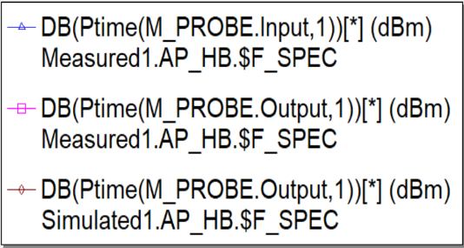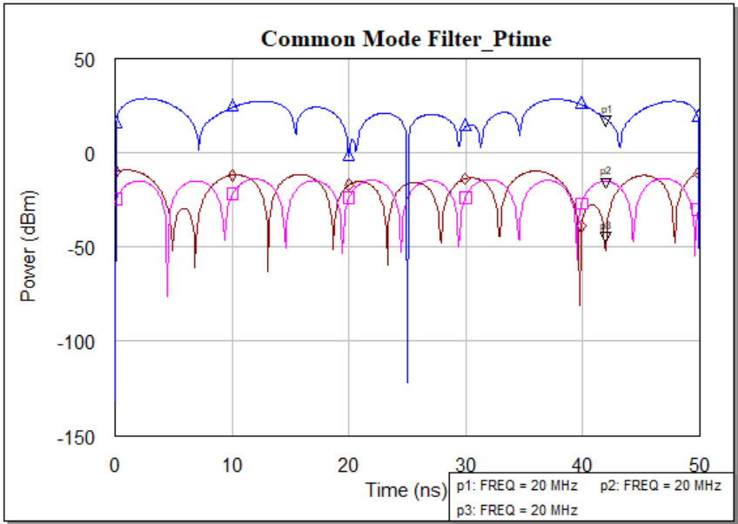

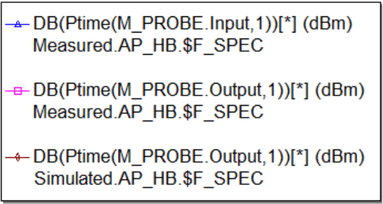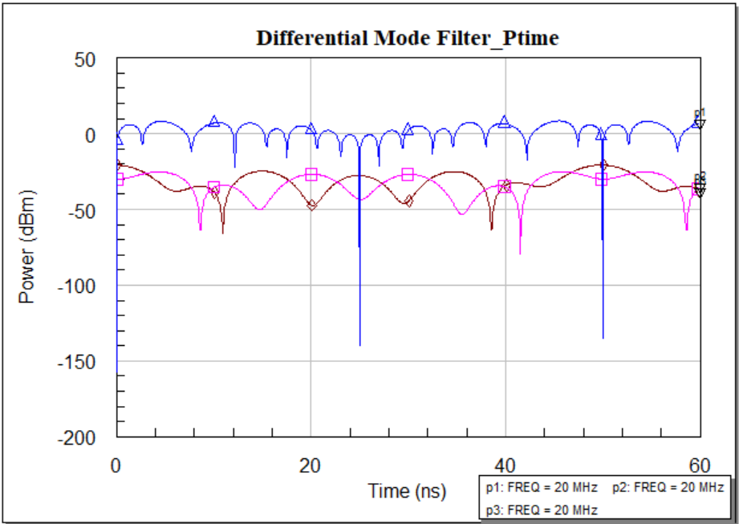

Figure 50: Power analysis of CM and DM filter for multi-tone input signal in time domain.

|  |  |  |  |  |
| --- | --- | --- | --- | --- |
| Frequency  (MHz) | Noise power (dBm) | Output power  (no cap) dBm | Output power  (2X100pF) dBm | Output power  (2X2200pF) dBm |
| 12 | -18.50 | -48.6 | -52.7 | -75.2 |
| 36 | -18.50 | -50.3 | -52.1 | -78.1 |
| 60 | -19.5 | -42.8 | -60.6 | -86.4 |
| 84 | -20.3 | -48.3 | -58.1 | -85.2 |
| 108 | -22.6 | -44 | -65.3 | -90.5 |
| 132 | -22.9 | -53.7 | -70.8 | -92.8 |
| 156 | -23.5 | -51.1 | -67.5 | -84.3 |
| 180 | -26.1 | -46.3 | -69.6 | -83.0 |
| 204 | -27.8 | -47.3 | -67.7 | -78.1 |
| 228 | -29.6 |  | -74.0 | -81.2 |

Table 01: Hardware measurement of CMF with 2 set of capacitors.

|  |  |  |  |  |
| --- | --- | --- | --- | --- |
| Frequency  (MHz) | Noise power (dBm) | Output power  (no cap) dBm | Output power  (1X100nF) dBm | Output power  (820pF &470pF) dBm |
| 12 | -18.50 | -24.6 | -49.1 | -29.5 |
| 36 | -18.50 | -35.6 | -51 | -47.6 |
| 60 | -19.5 | -33.8 | -44.9 | -59.6 |
| 84 | -20.3 | -38.6 | -47.3 | -48.1 |
| 108 | -22.6 | -33.7 | -41.3 | -48.2 |
| 132 | -22.9 | -41.1 | -47.9 | -45.2 |
| 156 | -23.5 | -31.3 | -37.3 | -37.9 |
| 180 | -26.1 | -30.4 | -34 | -31.1 |
| 204 | -27.8 | -30.8 | -34.4 | -33.9 |
| 228 | -29.6 |  |  |  |

Table 02: Hardware measurement of DMF with 2 set of capacitors.

 

Figure 51: a) Hardware simulation for CM filter, b) Hardware simulation for DM filter.

|  |  |  |  |  |  |  |
| --- | --- | --- | --- | --- | --- | --- |
| Frequency  (MHz) | Noise power (dBm) | Output power  (no cap) dBm | Output power  (2X100pF) dBm | | Output power  (2X2200pF) dBm | |
| Sym com | real com | Sym com | real com |
| 12 | -18.46 | -54.03 | -56.02 | -65.36 | -78.37 | -78.32 |
| 36 | -18.46 | -51.08 | -59.02 | -63.58 | -85.31 | -85.79 |
| 60 | -19.46 | -49.77 | -61.67 | -63.56 | -88.58 | -93.14 |
| 84 | -20.24 | -48.44 | -63.13 | -63.7 | -92.7 | -97.99 |
| 108 | -21.1 | -47.32 | -64.12 | -64.31 | -96.25 | -112.1 |
| 132 | -22.85 | -47.52 | -66.05 | -66.38 | -103.1 | -97.47 |
| 156 | -23.47 | -46.74 | -66.74 | -67.25 | -113.7 | -91.5 |
| 180 | -26.08 | -48.14 | -69.57 | -70.34 | -105.8 | -89.75 |

Table 03: Software measurement of CMF with 2 set of capacitors.

|  |  |  |  |  |  |  |
| --- | --- | --- | --- | --- | --- | --- |
| Frequency  (MHz) | Noise power (dBm) | Output power  (no cap) dBm | Output power  (1X100nF) dBm | | Output power  (820pF &470pF) dBm | |
| sym com | real com | sym com | real com |
| 12 | -18.46 | -37.53 | -33.59 | -39.71 | -43.07 | -42.61 |
| 36 | -18.46 | -45.77 | -62.45 | -65.51 | -59.07 | -57.65 |
| 60 | -19.46 | -49.01 | -69.25 | -70.41 | -63.94 | -61-94 |
| 84 | -20.24 | -49.82 | -71.29 | -73.2 | -61.14 | -57.63 |
| 108 | -21.1 | -49.33 | -71.37 | -74.71 | -54.47 | -61.0 |
| 132 | -22.85 | -49.01 | -71.36 | -73.88 | -70 | -73.52 |
| 156 | -23.47 | -46.61 | -69.17 | -71.25 | -74.39 | -78.23 |
| 180 | -26.08 | -45.16 | -67.87 | -69.77 | -77.35 | -81.99 |

Table 04: Software measurement of DMF with 2 set of capacitors.



Figure 52: a) Software simulation for CM filter, b) Software simulation for DM filter.



Figure 53: Noise power for both filter both in Software and Hardware platform.

Discussion: It is very important to reduce high power consumption and develop techniques to minimise power. As a result, power measurement is a major factor of this thesis activity. In Figure 50, a complete overview of input power and output power for the multi-tone signal has been plotted. Figure 51 explains the hardware power analysis simulation both for Common Mode Filter and Differential Mode Filter. As well as the software analysis is done for the both filters in Figure 52. Observing these figures, we can estimate that the output response is not close to the input response for those capacitor sets proposed. The variations are triggered by the very small change in capacitance values. This is observed that the power consumption is lower for those capacitor sets, we have proposed. This observation is same both for the hardware and software simulations. On the other hand, we also have power measurement for the noise source that we have built manually both in hardware and software. That has been plotted in Figure 53.

#### Measurement Comparison

##### Common Mode Filter





Figure 54: Comparison between Hardware and Software simulation with different components.

##### Differential Mode Filter





Figure 55: Comparison between Hardware and Software simulation with different components.

Discussion: An Electromagnetic Interference (EMI) filter is consist of two basic part, which are the Common mode part and the Differential Mode part. These two-part can be implemented individually considering all the parameters and simulation process in an equal manner. In this thesis work, we have implemented these two basic parts of an EMI filter and tested the variation in frequency domain replacing the parasitic components (capacitors). For a common mode part, the hardware and the software testing has been considered as following three criteria:

* Considering the Common Mode Choke as a Common Mode Filter,
* Considering the parasitic components value as they are being used in the market,
* Considering the parasitic components value focusing only on the trigger point.

# Chapter Five. Experimental approach and discussion

## Case Study 1: 230V 50Hz line

A common mode power line choke will be used to perform this case study where the inductance value is 2.2 mH and the rated voltage is 250V at 50Hz. A LISN network we have used as a Load. The schematic of a LISN have already shown in Figure 30 and the values of the components remain same. We are going to take the linear and nonlinear measurements using the same EMI filter standard design we have previously used across the LISN. The same X and Y capacitor set will be used to observe the variety of responses both in the Frequency and Time domain. A different Common Mode Choke is used to complete the case.

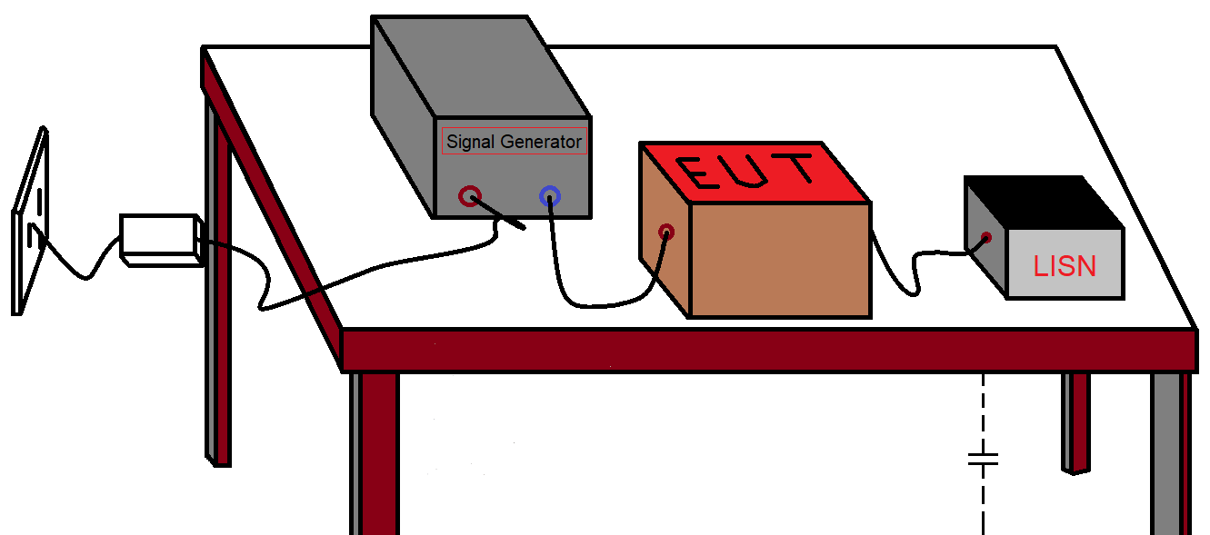

Figure 56: Model setup for the test.

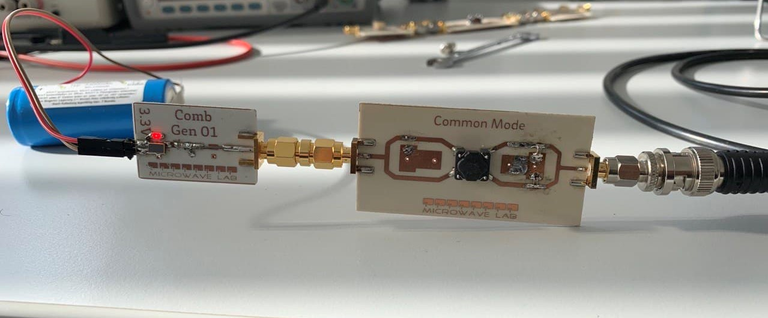

Figure 57: Circuit setup for the test.

### Linear simulation

In the linear operation the insertion loss will be ensured both in Common Mode Filter and Differential Mode Filter using 2 set of capacitors. The results will be compared for both filters.

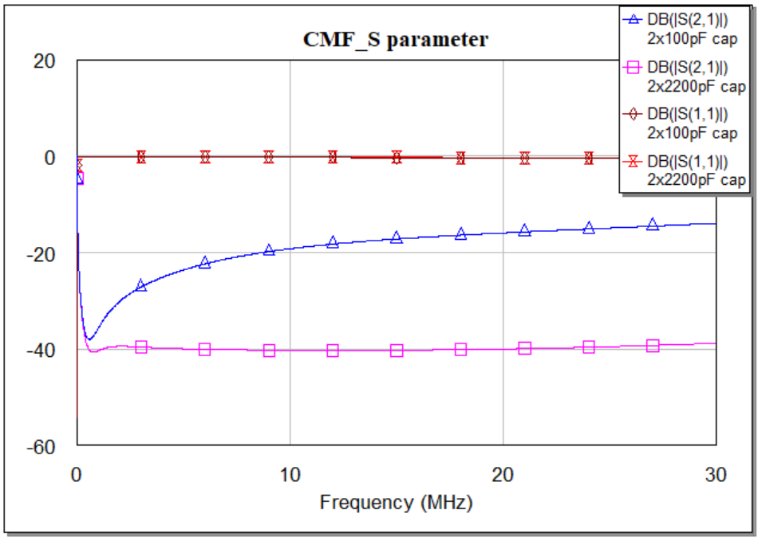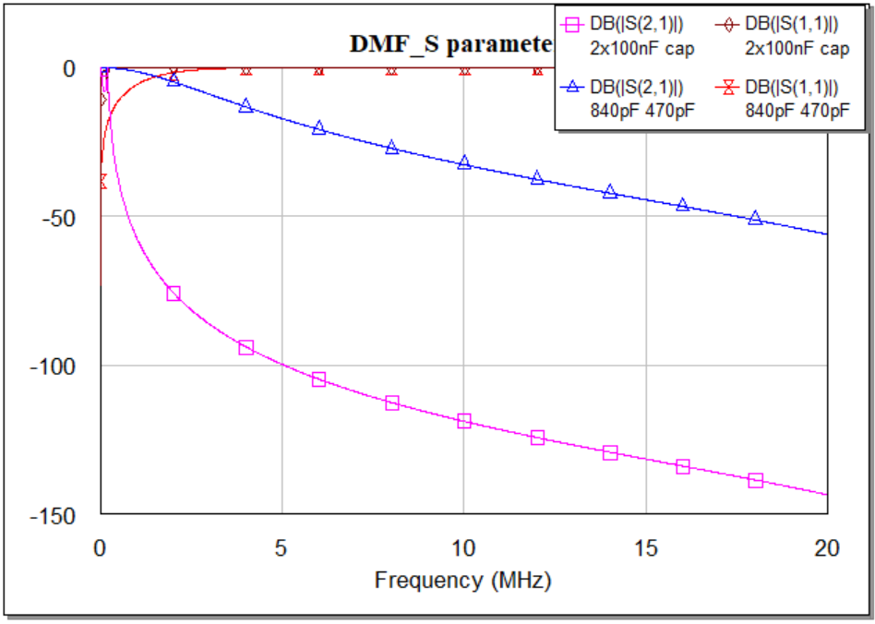

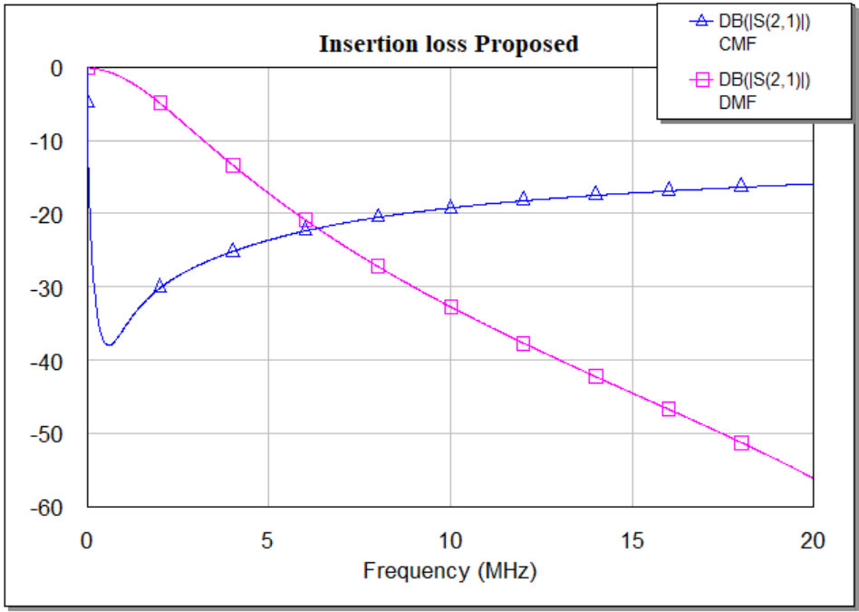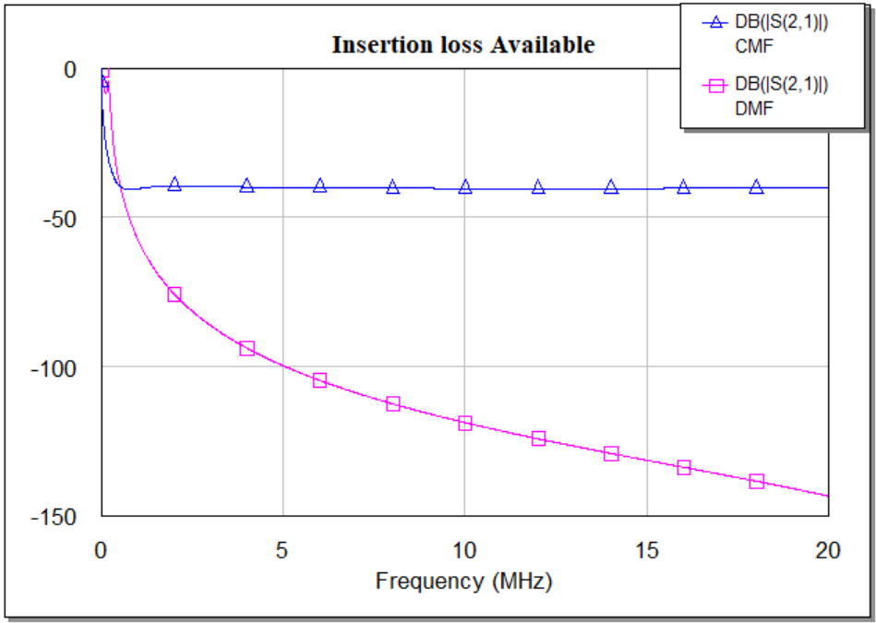

Figure 58: a) CMF s-parameters (s11, s21) for both 2x100pF cap and 2x2200pF cap

b) DMF s-parameters (s11, s21) for both 2x100nF cap and 840pF & 470pF cap

c) Comparison between CMF & DMF insertion loss (proprsed-2x100pF & 840,470pF)

d) Comparison between CMF & DMF insertion loss (available-2x2200pF & 2x100nF).

Discussion: For this specific case study as we have used a different model of choke having a different range of operating frequency. We have got different responses both for the Common Mode Filter and Differential Mode Filter. Considering the same standard filter design with the value of the capacitors, we have observed that in Figure 58, the insertion loss for the Common Mode Filter is lower than the previous filter. On the other hand for the Differential Mode Filter, the insertion loss is also lower for the capacitor set we have proposed.

### Nonlinear simulation

Nonlinear simulation can be divided into two domains. Here for the nonlinear simulation, we are using the same procedure. For time domain simulation, we have considered Common Mode Filter and Differential Mode Filter with Common Mode Choke and different set of capacitors as we have used before. Again, for frequency domain test we have simulated harmonic voltage and harmonic power with respect to the noise frequency. In the following we have plotted only the AWR simulated graph.

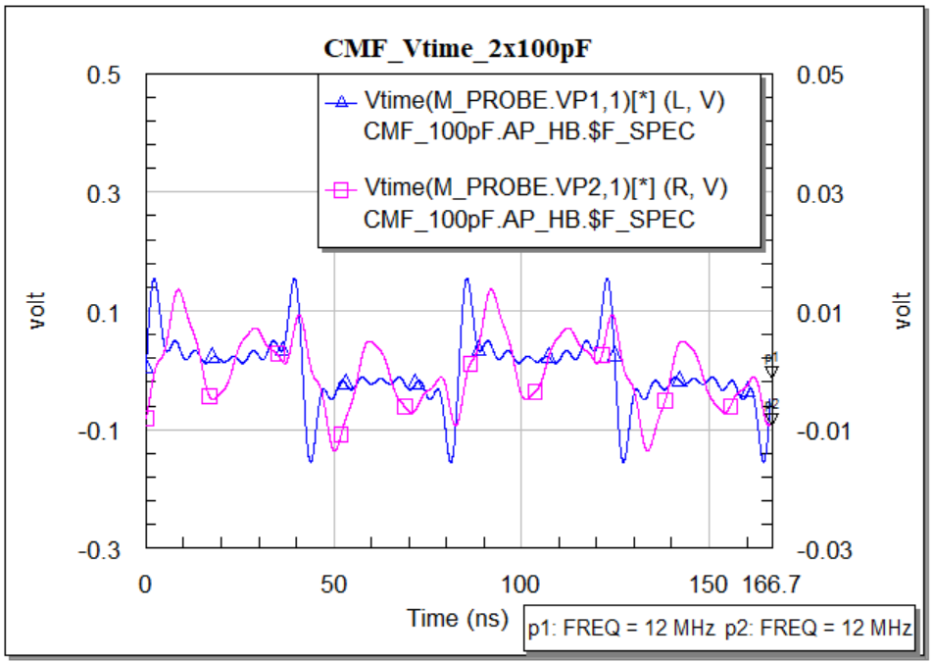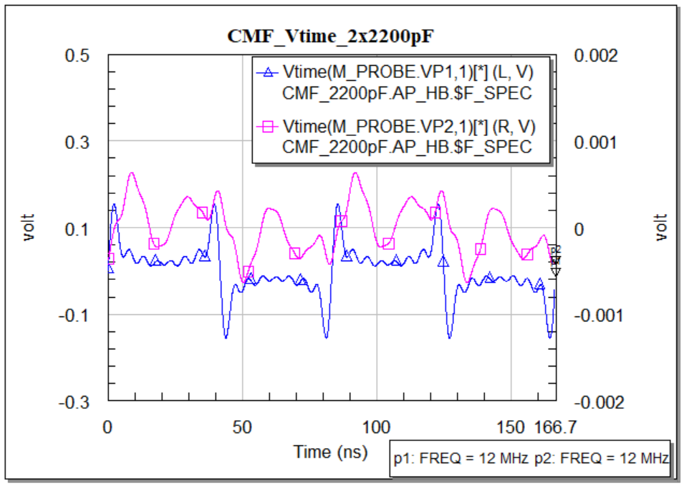

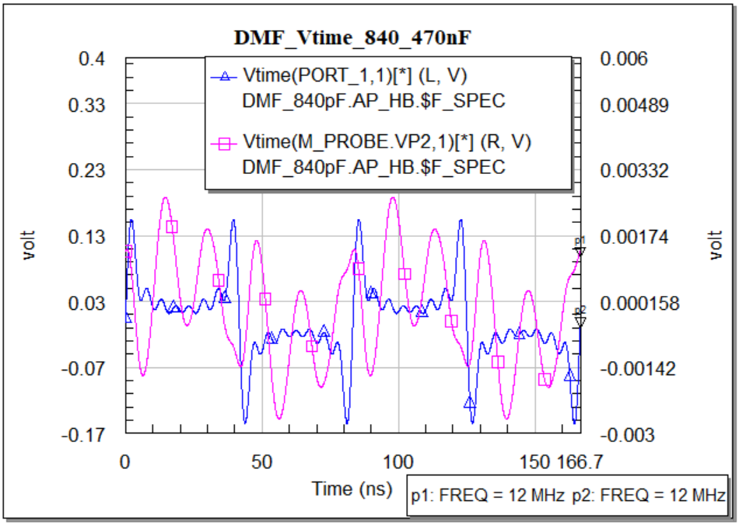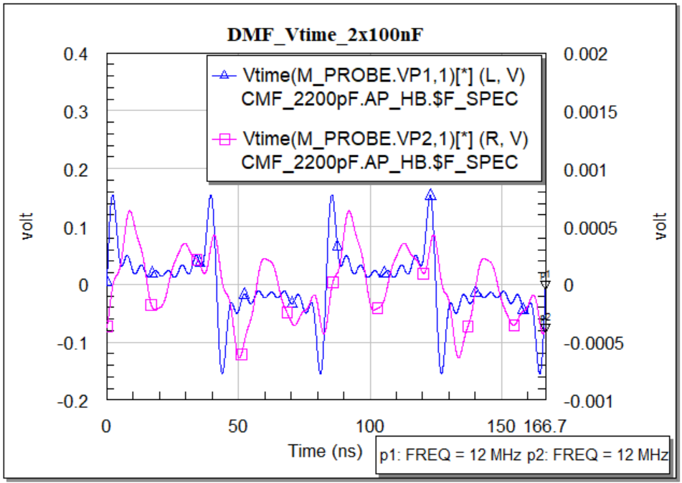

Figure 59: Time domain response of input and output CMF & DMF for 2 set of capacitor.

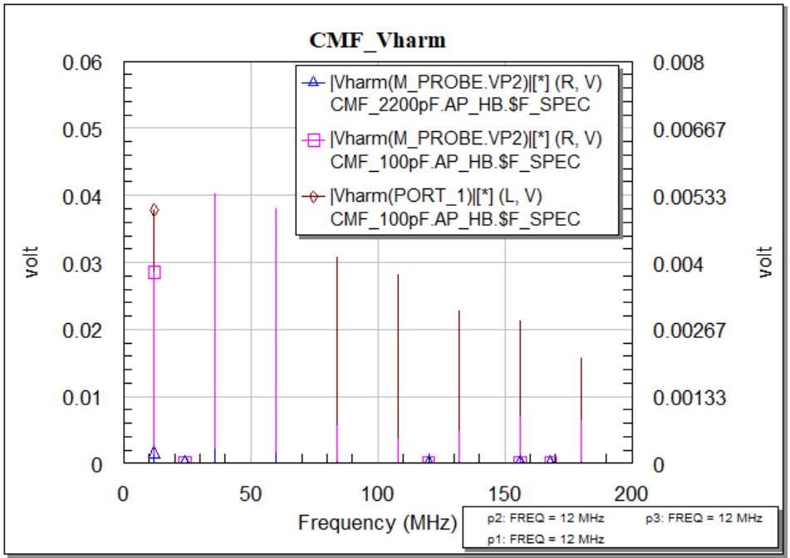

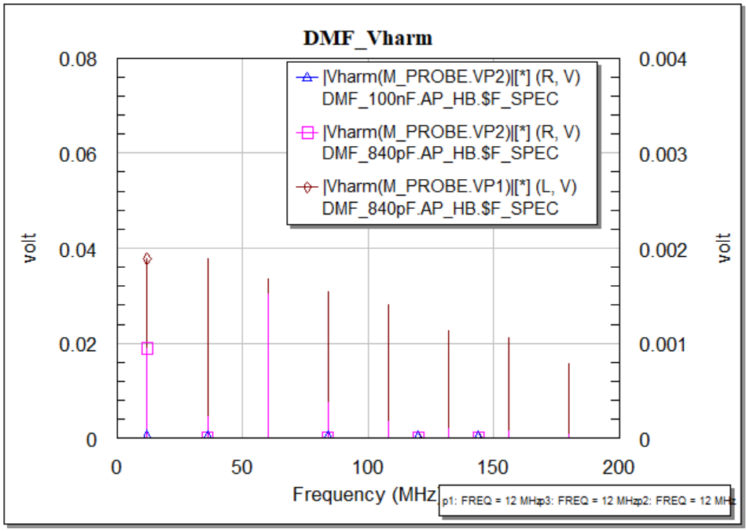

Figure 60: Frequency domain response of input and output harmonic voltage of CMF & DMF for 2 set of capacitors.

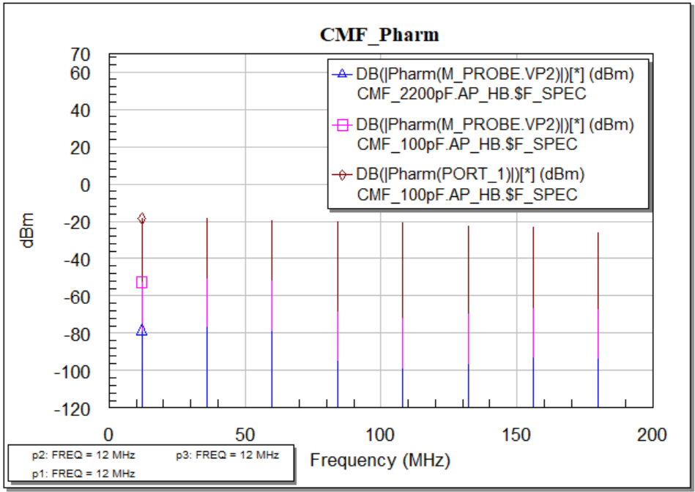

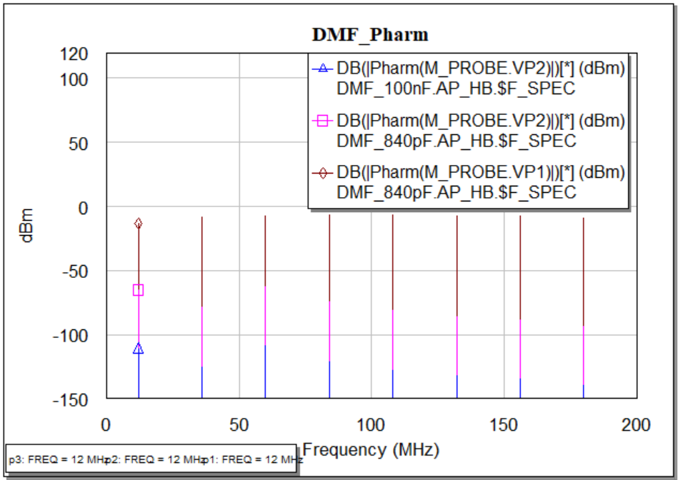

Figure 61: Frequency domain response of input and output harmonic power of CMF & DMF for 2 set of capacitors.

Discussion: We have measured the input, output results for the Common Mode Filter and Differential Mode Filter with the setup of 230V and 50Hz supply. In Figure 59, for the time-domain, the input response is different than the previous filter we have simulated and this is because of the Common Mode Choke. But the output response is not that satisfactory although, the magnitude is better than previous at some frequencies. In Figure 61, the harmonic voltage measurement in frequency domain response is also better than the filter we have previously built. It is seen that this power line Common Mode Choke of the specific model we have used here is good for filter designing in the low-frequency range.

## Case Study 2: Experimental Examples

### USB cables

The Universal Serial Bus (USB) is a standard for connecting computers and other electronic devices. The latest version of this standard is USB 3.0, and the data transfer speed is very high, which is why this cable is currently very common.

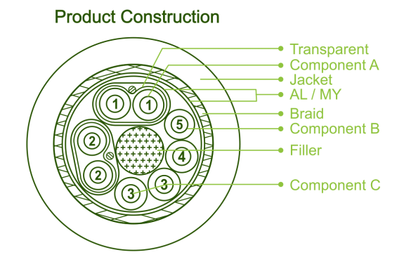 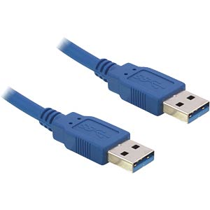

Figure 62: USB cable and its core layout [27].

All USB cables deliver 5 volts, only when it is connected to a high power device it can deliver a maximum of 12 volts. As we know that there are two pairs of cables inside a USB cable among those one is used for data and another one is used for power transmission. The frequency range of the USB standard is between 480 MHz and 960 MHz. However, since USB 1.0 operates at a maximum frequency of 12 MHz and the voltage is 5 volts, we will approach the nonlinear measurement of USB 1.0.

#### Components selection

Since the power supply can produce both common mode and differential mode noise in a wide range of frequencies so to minimize the conducted emissions the EMI filter characteristics must be analyzed. For that reason, some of the experiments needs to execute to observe the voltage and power variation. As we have already measured the EMI filter output (both power and voltage) providing harmonic noise, we will measure and observe what the voltage and power variation happens if we connect another source having 5volt rms with 12 MHz frequency. In that case, we will use the same filter without changing its standard structure, Common Mode Choke, and the X, Y capacitors and also not going to change the values.

 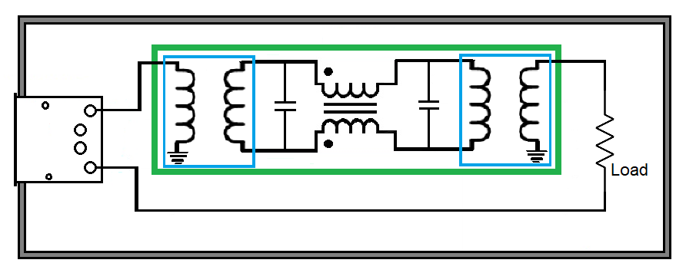

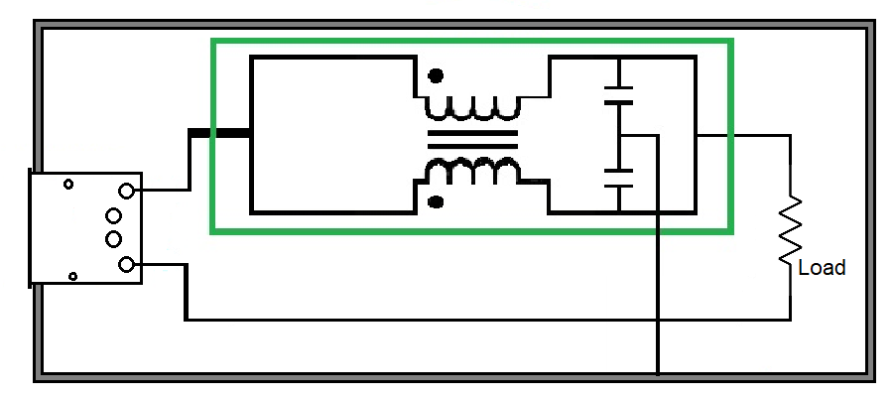

Figure 63: Circuit schematic of DM filter and CM filter with USB connection.

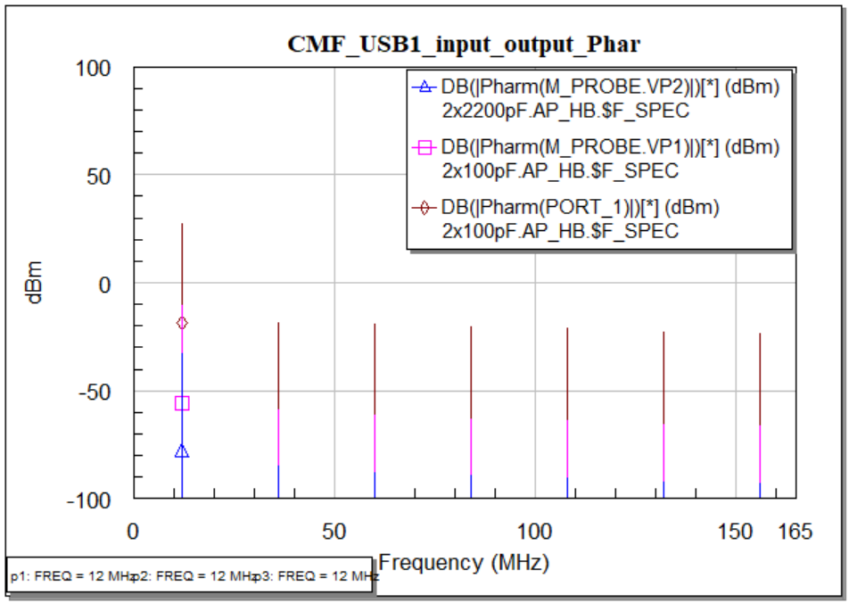

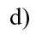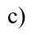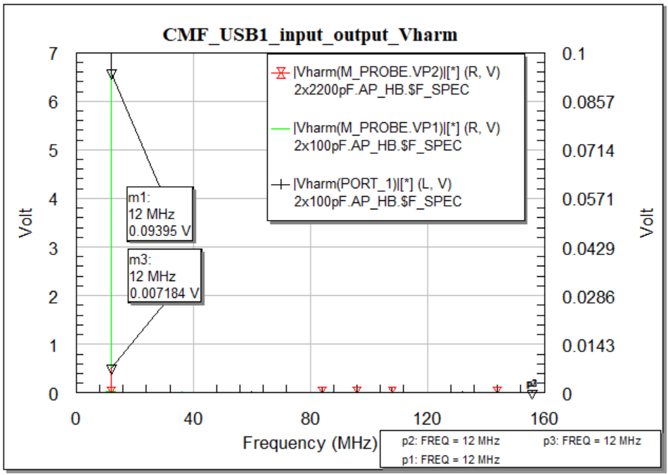

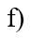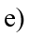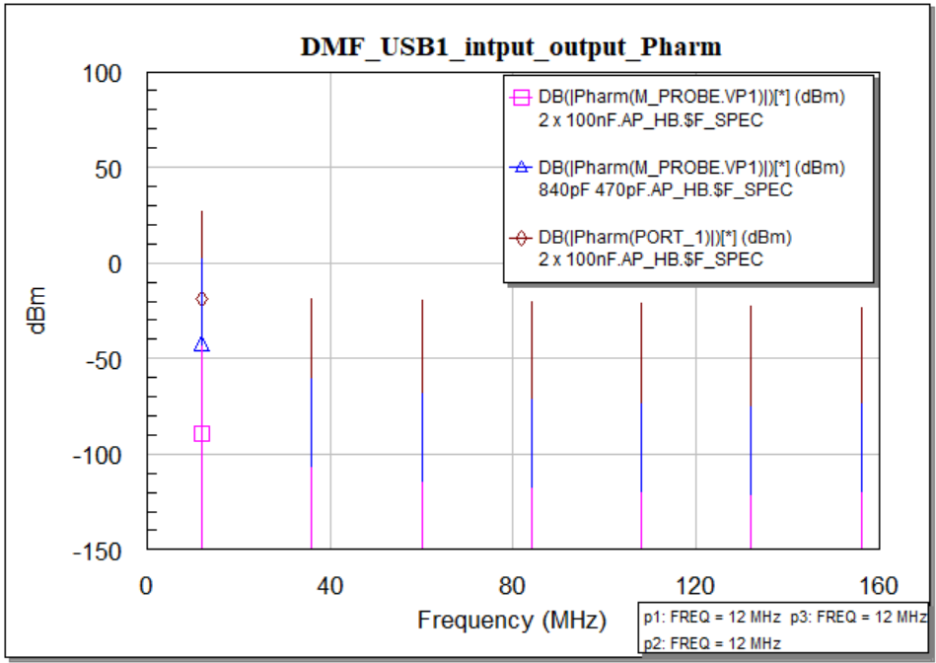

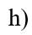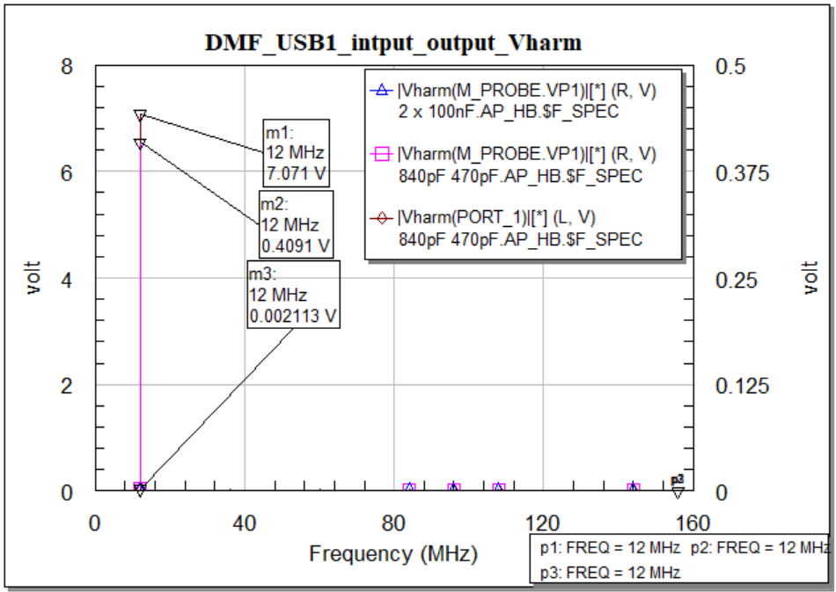

Figure 64: Common Mode Filter & Differential Mode Filter measurement for USB 1.0 cable towards the load a) CMF Power input and output in time domain (Pharm). b) CMF Input & Output harmonic power comparison. c) CMF voltage input and output in time domain (Vharm). d) CMF Input & Output harmonic voltage comparison. e) DMF Power input and output in time domain (Pharm). f) DMF Input & Output harmonic power comparison. g) DMF voltage input and output in time domain (Vharm). h) DMF Input & Output harmonic voltage comparison.

Discussion: Considering a USB 1.0 cable to test the input-output power of the filter is plotted in Figure 64. If we take a close look at the figure then we will see, at the operating frequency of the USB cable we get the higher response and the amount of power loss in the output is quite low. In this case study, we again can observe that the output response is better for the set of capacitors we have proposed. In the Common Mode Filter, the input voltage at 12 MHz is 7.071V and on the other hand for the available model using two 2200pF capacitor the output voltage is 7.18mV. But as we have proposed a capacitor set 100pF, we have got the output voltage 94mV. Similarly input power

### Ethernet cables

Ethernet cables carry broadband signals to Internet-connected devices. There are other variations of this cable that are only used for speed. The most commonly used Ethernet cables are unshielded twisted pairs. There are a total of four copper wires and each wire consists of two twisted wires. Each copper wire is covered with an insulating plastic layer. In an Ethernet, the electrical and optical properties are maintained by the physical layer and the data transmission layer. The line voltage is nearly 2.5 V. However, the processing bandwidth varies depending on the cable type. For cat5, the bandwidth is 100 MHz, while for cat6 Ethernet cables, it is 250 MHz. For cat6a, the bandwidth is much higher at 500 MHz. We will select one of the cables and test the input/output response including the noise signal.

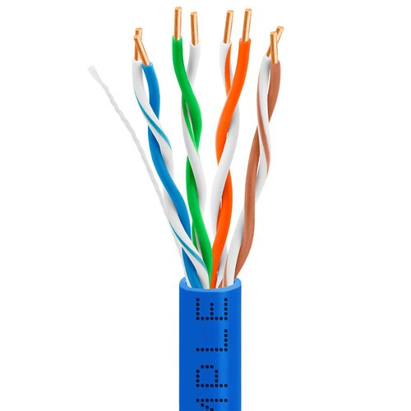

Figure 65: Ethernet cable and port having male and female port [28].

#### Common mode measurement

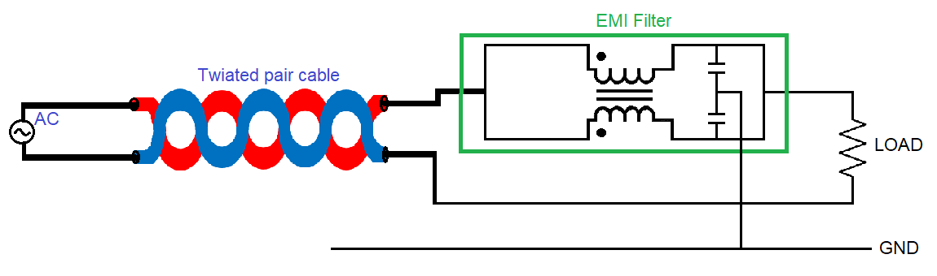

Figure 66: Circuit schematic with Common Mode Filter.

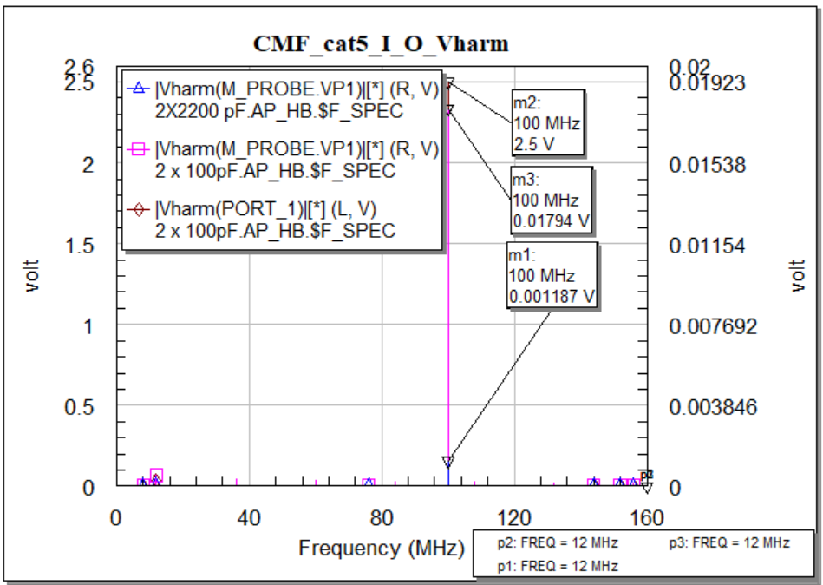

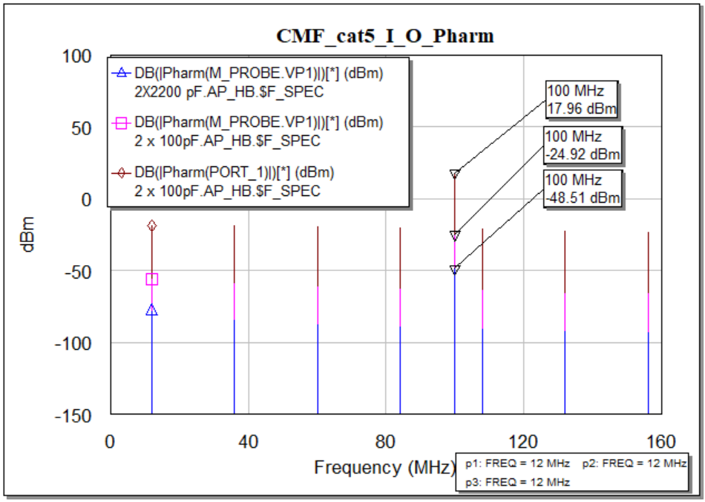

Figure 67: Common Mode Filter for cat5 Ethernet cable towards the load in frequency domain a) Voltage input AWR (Vharm) b) Voltage output Measured (Vharm) c) Power input AWR (Pharm) d) Power output Measured (Pharm).

#### Differential mode measurement

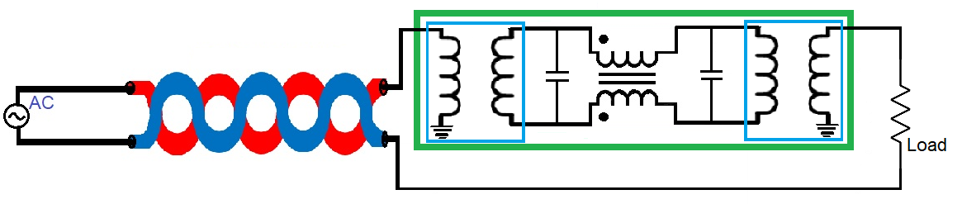

Figure 68: Circuit schematic with Differential Mode Filter.

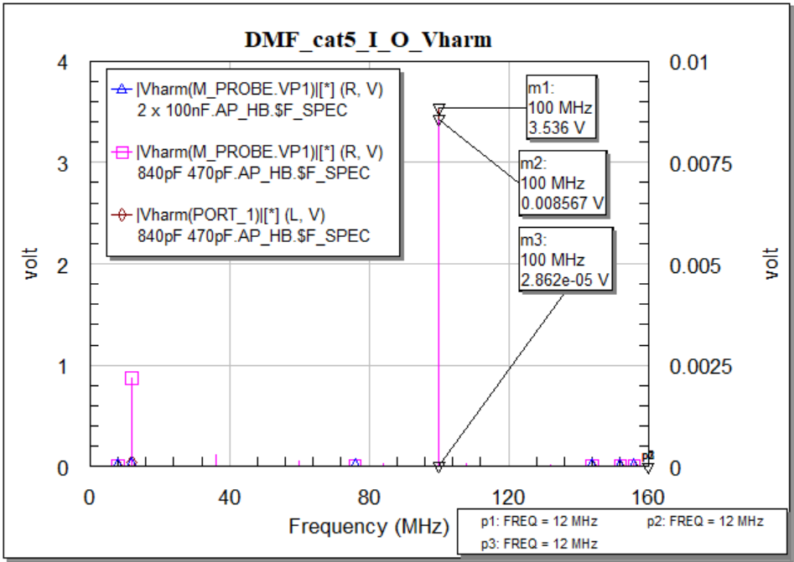

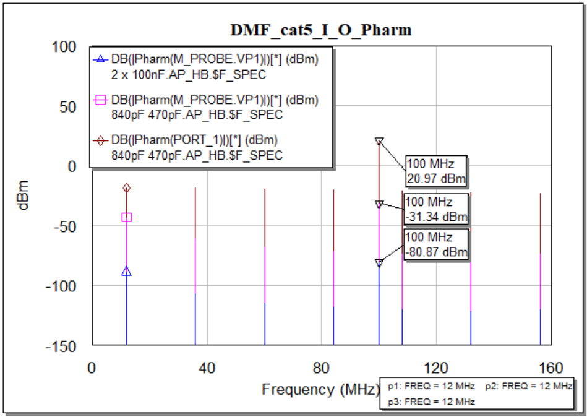

Figure 69: Differential Mode Filter for cat5 Ethernet cable towards the load in frequency domain a) Voltage input AWR (Vharm) b) Voltage output Measured (Vharm) c) Power input AWR (Pharm) d) Power output Measured (Pharm).

Discussion: For the second case study we have taken Ethernet cable (cat5) and in Figure 69 we have plotted some responses in the frequency domain only to observe the power variation and compare with the previous case study. We have seen as the operating frequency is set at 100MHz, the power response is higher. The main thing we have to observe is the output response which is not that better than the previous case. Although, again the output power is better for the capacitor we have proposed.

# Conclusion

In this paper, an EMI filter is designed based on the noise properties with low frequency. As we have selected the Common Mode Choke having an operating frequency in the low range, the EMI filter has been designed as a low pass filter in the entire research and measurement as well. The main goal of this paper is to design an EMI filter, to simulate the filter with different valued components in the different frequency ranges, estimate the components value at which the transmitted attenuation is low, and to measure the power changes in the frequency and the time domain. All the simulations regarding linear and nonlinear characteristics of the Common Mode Filter and Differential Mode Filters are properly investigated and measured. Some comparisons like using of different signal source, using single and multi-tone were also performed to make sure the performances. The low-frequency profile of the Common Mode Choke is used in the EMI filter made it possible to study and implement. The influence of the parasitic elements are observed in different domains. This EMI filter model is very useful for investigating the impact of the parasitic couplings on its performances. Some analysis have been performed in order to match the resulting response of the components with the filter output. Some of the results were unexpected due to the noise characteristics, component properties, and the transient properties. Starting from the frequency test, many other techniques like coupling mechanism, grounding, filtering, PCB layout designing, linear and nonlinear including the multi-tone signals have been applied to test and to reduce the effect of EMI. All these techniques guided to design the EMI filter. It is observed that the best way to reduce the conducted emissions induced, is to stop it at the entry and the exit point of a module. The next step of this thesis work is to measure the radiated emissions using these passive components that have been used to design the EMI filter.

# References

|  |  |
| --- | --- |
| [1] | W. contributors, “Electromagnetic compatibility,” Wikipedia, The Free Encyclopedia., [Online]. Available: https://en.wikipedia.org/w/index.php?title=Electromagnetic_compatibility&oldid=1043327448. [Accessed 9 September 2021 14:37 UTC]. |
| [2] | W. contributors, “Electromagnetic interference,” Wikipedia, The Free Encyclopedia, 17 September 2021 18:02 UTC. [Online]. Available: https://en.wikipedia.org/w/index.php?title=Electromagnetic_interference&oldid=1044909084. [Accessed 3 October 2021]. |
| [3] | A. V. S. Bhd, “ME1400 EMI AND EMC,” [Online]. Available: https://ppt-online.org/152151. [Accessed 11 October 2021]. |
| [4] | P. M. a. S. RAMAN, “Electromagnetic Interference (EMI) Measurement and and Reduction Techniques,” *PROGRESS AND CHALLENGES IN DEVELOPING ELECTROMAGNETIC INTERFERENCE MATERIALS,* vol. 49, p. 24, 2020. |
| [5] | K. Bellero, “EMI FILTER DESIGN,” 23 May 2018. [Online]. Available: https://impulse.schaffner.com/en/engineers-guide-to-designing-emi-filter. [Accessed 1 October 2021]. |
| [6] | E. Tran, “Environment/EMC/EMI,” Spring 1999. [Online]. Available: https://users.ece.cmu.edu/~koopman/des_s99/environment/. [Accessed 1 October 2021]. |
| [7] | W. D. V. M. Violette J.L.N., “Electromagnetic Compatibility Handbook. Springer, Dordrecht.,” in *Sources of Electromagnetic Interference*, Springer, Dordrecht, 1987, pp. 13-15. |
| [8] | Digikey, “744272102,” [Online]. Available: https://www.digikey.com/en/products/detail/w%C3%BCrth-elektronik/744272102/1638897. [Accessed October 2021]. |
| [9] | G. BOCOCK, “Match modular EMI AC line filters to application’s DC supply needs,” 28 FEBRUARY 2020. [Online]. Available: https://www.edn.com/match-modular-emi-ac-line-filters-to-applications-dc-supply-needs/. [Accessed 5 October 2021]. |
| [10] | J. Preibisch, “Effectively protecting super-speed interfaces against EMI,” 24 JANUARY 2019. [Online]. Available: https://efficiencywins.nexperia.com/efficient-products/protecting-super-speed-interfaces-against-emi.html. [Accessed 7 October 2021]. |
| [11] | K. A. KG, “EMC Considerations for Auxiliary Inverters in Electric Vehicles Applications,” 2021. [Online]. Available: https://www.kebamerica.com/blog/emc-considerations-in-electric-vehicle-applications/. [Accessed October 2021]. |
| [12] | C. Kathalay, A practical approach to Electromagnetic compatibility, Pune, India: EMC Publications, Pune, 2014. |
| [13] | C. Paul, Introduction to Electromagnetic Compatibility, John Wiley & Sons,, 1992. |
| [14] | Tech Web, “Differential (Normal) Mode Noise and Common Mode Noise－Causes and Measures,” Tech web, 1997-2021. [Online]. Available: https://techweb.rohm.com/knowledge/emc/s-emc/01-s-emc/6899. [Accessed 13 October 2021]. |
| [15] | R. Cheang, “Electrical Noise Suppression and Common Mode Choke,” Electronics360, 25 May 2018. [Online]. [Accessed 15 October 2021]. |
| [16] | W. contributors, “Comb generator,” Wikipedia, The Free Encyclopedia., 26 July 2020 08:02 UTC. [Online]. Available: https://en.wikipedia.org/w/index.php?title=Comb_generator&oldid=969574770. [Accessed 15 October 2021]. |
| [17] | W. contributors, “Line Impedance Stabilization Network,” Wikipedia, The Free Encyclopedia., 9 October 9 October 2021 09:33 UTC. [Online]. Available: https://en.wikipedia.org/w/index.php?title=Line_Impedance_Stabilization_Network&oldid=1049011943. [Accessed 18 October 2021]. |
| [18] | W. contributors, “Two-port network,” Wikipedia, The Free Encyclopedia., 18 June 2021 00:50 UTC. [Online]. Available: https://en.wikipedia.org/w/index.php?title=Two-port_network&oldid=1029116605. [Accessed 19 October 2021]. |
| [19] | Cadence System Analysis, “How to Calculate a Transfer Function From S-Parameters,” 2021. [Online]. Available: https://resources.system-analysis.cadence.com/blog/2020-how-to-calculate-a-transfer-function-from-s-parameters. [Accessed 21 October 2021]. |
| [20] | tutorialspoint, “Network Theory - Two-Port Networks,” tutorialspoint, 2021. [Online]. Available: https://www.tutorialspoint.com/network_theory/network_theory_twoport_networks.htm. [Accessed 20 October 2021]. |
| [21] | EMI analyst software, “How to Calculate Filter Insertion Loss,” 2021. [Online]. Available: https://www.emisoftware.com/blogs/emc-analysis-calculate-filter-insertion-loss/. [Accessed 22 October 2021]. |
| [22] | giangrandi.ch, “Transmission line reflections, standing waves and return loss,” 2012. [Online]. Available: https://www.giangrandi.org/electronics/anttool/swr.shtml. [Accessed 14 October 2021]. |
| [23] | W. contributors, “Harmonic balance,” Wikipedia, The Free Encyclopedia., 1 October 2021 15:26 UTC. [Online]. Available: https://en.wikipedia.org/w/index.php?title=Harmonic_balance&oldid=1047588600. [Accessed 19 October 2021]. |
| [24] | Evaluation Engineering, “Simulating EMI Filters With Time-Domain Waveforms,” 1 December 1995. [Online]. Available: https://www.evaluationengineering.com/home/article/13000347/simulating-emi-filters-with-timedomain-waveforms. [Accessed 22 October 2021]. |
| [25] | B. A. M. E. Yusri Maslamani, “Multi-tone Test,” 2014. [Online]. Available: https://eng-old.najah.edu/graduation-projects/7128. [Accessed 5 October 2021]. |
| [26] | V. White, “S-Parameter Measurements Basics for High Speed Digital Engineers,” 25 October 2017. [Online]. Available: https://literature.cdn.keysight.com/litweb/pdf/5991-3736ENDI.pdf. [Accessed 17 October 2021]. |
| [27] | dongnan, “dongnan cables,” 2021. [Online]. Available: https://dongnan.com.hk/USB_cable/. [Accessed 15 October 2021]. |
| [28] | K. C. P. Limited, “Networking Cable,” [Online]. Available: https://www.kubheracable.com/networking-cable.html. [Accessed 26 October 2021]. |
| [29] | Textronix, “What is EMC/EMI Testing?,” tex.com, 2021. [Online]. Available: https://www.tek.com/what-is-emc-emi-testing. [Accessed 13 September 2021]. |
| [30] | M. BERMAN, “All about EMI filters,” 1 October 2008. [Online]. Available: https://www.electronicproducts.com/all-about-emi-filters/#. [Accessed 5 October 2021]. |
| [31] | Coilcraft, “Common Mode Filter Design Guide,” 2007. [Online]. Available: https://www.coilcraft.com/getmedia/9c231e30-04a2-4463-b679-c38b99b2669e/doc191_CMFiltDesign.pdf. [Accessed 7 October 2021]. |
| [32] | Biricha, “EMC Filter Design Part 8: EMC Common Mode Filter Design and Component Selection,” 4 March 2019. [Online]. Available: https://www.youtube.com/watch?v=UOCsqNtRL74. [Accessed 3 June 2021]. |
| [33] | J. P. G. P. a. a. G. K. P.V.Y. Jayasree, “EMI Filter Design for Reducing Common-Mode and Differential-Mode Noise in Conducted Interference,” *International Journal of Electronics and Communication Engineering. ,* vol. 5, p. 12, 2012. |
| [34] | M. Rine, “EMI Conducted and Radiated Emissions,” vac magnetics, March, 2016. |
| [35] | W. contributors, “Conducted emissions,” Wikipedia, The Free Encyclopedia., 17 May 2021. [Online]. Available: https://en.wikipedia.org/w/index.php?title=Conducted_emissions&oldid=1023580121. [Accessed 11 October 2021]. |
| [36] | Coilcraft, “A Guide to Understanding Common Mode Chokes,” 2021. [Online]. Available: https://www.coilcraft.com/en-us/edu/series/a-guide-to-understanding-common-mode-chokes/. [Accessed 16 October 2021]. |
| [37] | Mathworks, “S-Parameter,” The MathWorks, Inc., 2021. [Online]. Available: https://de.mathworks.com/discovery/s-parameter.html. [Accessed 20 October 2021]. |
| [38] | Cadence PCB Design and analysis, “Low Pass Filter Transfer Functions,” 2021. [Online]. Available: https://resources.pcb.cadence.com/blog/2019-low-pass-filter-transfer-functions. [Accessed 21 October 2021]. |
| [39] | W. contributors, “Propagation constant,” Wikipedia, The Free Encyclopedia., 11 October 2021 20:04 UTC. [Online]. Available: https://en.wikipedia.org/w/index.php?title=Propagation_constant&oldid=1049432032. [Accessed 23 October 2021]. |
| [40] | Europens Passive Components Institute, “An introduction to insertion loss and filter capacitor performance,” 27 November 2019. [Online]. Available: https://passive-components.eu/an-introduction-to-insertion-loss-and-filter-capacitor-performance/. [Accessed 22 October 2021]. |
| [41] | K. Z. M. G. B. D. Y. L. Ying Liu, “A theoretical and practical clarification on the calculation of reflection loss for microwave absorbing materials,” vol. 8, p. 38, 25 January 2018. |